

|  |  |  |
| --- | --- | --- |
| **Module Code** | **:** | CT046-3-2-SDM –Systems Development Methods |
| **Intake Code** | **:** | APU2F2411CS(AI)/APU2F2411(BIS) |
| **Lecturer Name** | **:** | Nurul Izzatie Husna Binti Muhamad Fauzi |
| **Hand in Date** | **:** | 16 February 2025 |
| **Tutorial No.** | **:** | T36 & T34 |
| **Group No.** | **:** | Group 15 |
| **Group Leader** | **:** | Tee Ching Ying |

|  |  |
| --- | --- |
| **Student ID** | **Student Name** |
| TP072694 | Tee Ching Ying |
| TP070517 | Kate Lim Jia Yee |
| TP070026 | Lau Jie Yin Alfy |
| TP071290 | Manreen Kaur A/P Jagjit Singh |
| TP086065 | Ong Kai Ying |

Table of Contents

1.0 Project Planning 4

1.1 Problem Statement 4

1.2 Scopes and Objectives 5

Scopes 5

Objectives 5

1.3 Project Scheduling 6

2.0 Agile Principles and IS Methodologies 6

2.1 Agile Principles 6

Manreen Kaur (TP071290) 6

Tee Ching Ying (TP072694) 8

Kate Lim Jia Yee (TP070517) 9

Lau Jie Yin Alfy (TP070026) 10

Ong Kai Ying (TP086065) 11

2.2 IS Methodologies 12

Rational Unified Process (RUP) 12

Waterfall Methodology 15

Spiral 17

Rapid Application Development (RAD) 18

Scrum Methodology 20

3.0 System Analysis 22

3.1 Business Intelligence analysis - SWOT 22

3.2 System Analysis for Eventure Event Management System: Project Analysis Approach 24

4.0 Design 27

4.1 Use Case Diagram 27

4.2 Class Diagram 28

4.3 State Machine Diagram 29

4.4 Activity Diagram 34

4.5 Sequence Diagram 37

5.0 Implementation and Deployment 39

5.1 Construction Tools 39

5.2 Proof of Concept 40

5.3 Testing 78

5.4 System Deployment 79

6.0 References 82

7.0 Workload Matrix 92

# Project Planning

## 1.1 Problem Statement

Firstly, Eventure is facing several challenges come from its reliance on manual processes, which restrict its efficiency and growth potential. Operational inefficiencies, such as time-consuming manual tasks and a lack of clear task visibility, make it difficult to track event progress and coordinate effectively. Disorganized data further make matters worse, as accessing critical information about clients, vendors, and events become slow and error prone. Clients face inconvenient booking experience due to the absence of an online platform to view services or make bookings, and the lack of automated updates leaves them disconnected from the planning process thereby leading to unhappiness and lost business opportunities.

However, vendor and resource management is another serious issue, as the company lacks a centralized system to monitor vendor performance or manage contracts efficiently, resulting in errors and inefficiencies. Manual financial tracking adds to the complexity, making budgeting and invoice management prone to errors and delays. As the business expands, scalability becomes a growing concern, and the inability to integrate with marketing tools limits efforts to attract new clients. Moreover, the absence of a structured feedback system prevents the company from identifying areas for improvement, further impacting service quality.

Seeking support from on manual processes also increases the risk of human errors, such as incorrect data entries and missed deadlines, which can harm client satisfaction and event delivery in order to decrease client loyalty. Without automation, Eventure risks falling behind competitors who offer more streamlined and personalized services. Therefore, to overcome these challenges, implementing a comprehensive Event Management Information System is crucial. Such a system would streamline operations, improve client engagement, and support sustainable growth, enabling Eventure to meet increasing client demands and maintain its competitive edge in the event planning industry.

## 1.2 Scopes and Objectives

### Scopes

The Eventure Information System will minimize manual work and improve operational efficiency like managing client questions, event specifics, vendor collaboration, and logistical arrangements by automating important processes. The system will document extensive event specifics including client details, location, date, number of guests, and agenda, plus a task management function to allocate and supervise tasks. Instant updates about event status and milestones reached will guarantee smooth progress tracking.

The system will integrate a vendor and resource management module providing a centralized database for preferred vendors, including contact details, services, pricing, contracts, and agreements. Vendor performance tracking of feedback and ratings will inform future selections, ensuring quality service delivery.

A client engagement module will include a web-based client portal for viewing event details, direct communication, and accessing planning tools. Automated notifications will enhance client experience by sending timely reminders and updates. A feedback system will allow clients to share post-event input, enabling continuous improvement.

The financial management component will track event-specific expenses and revenue by generating invoices for deposits and final payments and maintaining records of payments received and balances. Budget reporting will analyze spending, profitability, and financial performance for strategic insights.

Designed to be scalable, the user-friendly system will integrate with marketing resources for client acquisition and support future growth. Developed within RM75000 budget within five-month timeline for planning, analysis, design, and implementation phases. Project aims to enhance efficiency, improve client relationships, and secure a competitive edge in event planning.

### Objectives

The Eventure project aims to streamline operations. The new Information system can reduce the manual workload and improve efficiency in event planning and processing. In this case, Samantha can reduce the need to handle multiple tasks manually, some tasks can be assigned to the Information system. It helps Samantha to improve the quality of their work.

The Eventure project also aims to enhance client relationships by providing a seamless, user-friendly experience for clients through the client portal. With the new Information system, Samantha’s customer will be able to keep track on the event details easily. Additionally, new system allow customer to provide feedback, enabling Samantha to review for the client feedback and make improvements on her business.

## 1.3 Project Scheduling

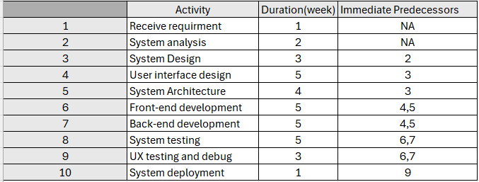  
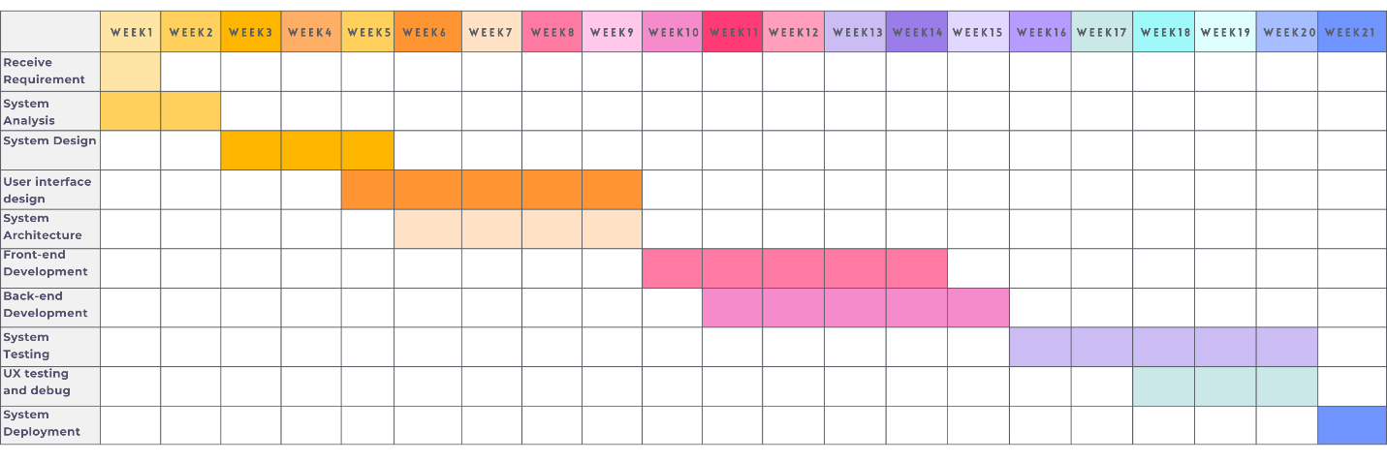

# 2.0 Agile Principles and IS Methodologies

## 2.1 Agile Principles

### Manreen Kaur (TP071290)

*“Customer Satisfaction by Early and Continuous Delivery of Valuable Software.”*

This principle ensures progress is visible to the client through early, incremental deliveries. For Eventure, this means delivering prototypes, such as the client portal or event management features, before the system is fully complete. These early releases allow Samantha to see tangible results and provide feedback (Platinumedge, 2024)

To implement this, the project would follow an incremental delivery approach, dividing work into sprints focused on high-priority features like vendor databases or financial tools. Regular feedback loops after each sprint enable Samantha to review functionality and request adjustments, ensuring alignment with her vision. A release planning strategy prioritizes early delivery of high-value components, such as financial tracking to maximize immediate utility. This also acts as a risk mitigation strategy as continuous validation reduces the chances of misaligned requirements. (Platinumedge, 2024)

“*Welcoming Changing Requirements, Even in Late Developments.”*

Event planning is dynamic, requiring the system to adapt to evolving client needs. This principle ensures flexibility to accommodate changes without disrupting progress.

The project will adopt adaptive planning with a flexible backlog for new requirements, such as milestone tracking. Collaborative decision-making involving Samantha will prioritize changes using tools like the MoSCoW framework, ensuring the focus remains on critical needs. A modular development approach will isolate functionalities such as client portal, vendor management and others to simplify updates. Additionally, a formalized change in management process ensures changes are reviewed, documented, and integrated effectively. (Platinumedge, 2024)(ProductPlan, 2024)

Time-boxing within sprints allows for adjustments without derailing the timeline, while continuous integration practices maintain system stability when incorporating new changes. These strategies ensure the system remains relevant and reliable, meeting Samantha’s evolving requirements.  (Jalote, 2004)

By applying these principles, the Eventure project will be flexible, client-focused, and well-positioned for success in a competitive industry. Plus, it can enhance project agility, ensuring a responsive and value-driven development process.

### Tee Ching Ying (TP072694)

*“Project are built around motivate individual, who should be trust. Give them the environment and support they need and trust them to get the job done.”*

It expresses how important it is to assign individuals to the project based on ability and position required to ensure project success. The leaders of agile teams should support the members by providing them with the resources, tools, and access they require. They also focus on ensuring the availability of teams in terms of the environment which includes culture, people as well as external processes, and after that trusting in them to have the goal. In addition, listening to the members' opinions is one way of showing the importance and making them enthusiastic. Giving the opportunity for every single team member to express themselves is also one way that results in good performance by all members. An effective agile leader will empower the teams to pass value by providing the resources required to achieve advice when needed, serving the teams, and focusing on the outcome. The most important component of this principle is giving people and teams autonomy and trusting them. Everyone’s responsibility should be clearly defined before work starts. Micromanagement should also be avoided.

For example, the team leader ensures that the developer knows about requirements and the approach regarding a new system. The knowledge of "How to create" would be along the process by the delivery team itself, but the focus will remain on "What is needed" and "Why it is needed" to create the system. Instead of micromanaging, this mindset aims to support when obstacles arise and provide ideas for potential solutions during the sprints. (Iqbal, 2022) (Molina, 2022)

*“Face to face conversation is the best form of communication (co-location)”*

It emphasizes efficient communication and collaboration with developers, which means transferring the discussions away from instant messaging along with emails and toward more face-to-face engagement. Applying this approach is not limited to physical interactions nowadays, but it emphasizes the value of deep connections and discussions even when conducted over online video conference platforms like Zoom, Google Meet, and others. Real-time face-to-face communication of information is better than texting. For remote teams, online meetings and regular phone calls remain the most effective communication methods, even though the speed and simplicity of email and texting.

For example, in case study, this principle should be used by setting up a daily meeting to update the development progress of event system. Besides that, brainstorming sessions, sprint planning meeting, collaborative backlog grooming sessions, frequent demos and pair-programming are also important to follow through the creation of this project. This principle's primary objective is to motivate developers and product people to interact in real time with the needs and the high-level strategy guiding those things. (Iqbal, 2022) (Molina, 2022)

### Kate Lim Jia Yee (TP070517)

*“Continuous Attention to Technical Excellence and Good Design”*

In fact, technical excellence and good design are key in building a successful software system. It can ensure the software is high quality, easy to maintain, as well as flexible and allows us to adapt to changing needs by focusing on technical excellence. Even better, a clean and well-structured code not only will make the system more reliable and efficient but also reduce long-term costs and make it easier to scale. Moreover, a good design helps lower the need for frequent updates and reduces the technical problems that could slow down future progress. (Medeiros, 2021) Ultimately, it enables teams to deliver a strong and high-quality system that meets user expectations and supports future improvements. (Chow, 2022) Also, a well-designed system also provides users with a smooth user experience. From booking events to managing vendors, every part of the system works together effectively, which may help maintain Eventure’s reputation and keep their client satisfied. The first strategies we would take to implement include that we will ensure that the system evolves with clean and efficient code by regularly revisiting and improving existing code. For instance, whenever the event booking logic is too complicated, we will start refactoring them and make the process easy and simple to implement future updates and enhancements. Furthermore, the next strategy we would take is we will incorporate monitoring tools in order to track system performance, such as response times, server loading times, and the like. By doing this, it can ensure the platform remains responsive even during peak usage such as during a popular wedding season. (Guimaraes, 2022)

*“Simplicity – The Art of Maximizing the Amount of Work Not Done”*

Simplicity is to deliver maximum value with minimal effort by avoiding unnecessary complexity in design, development as well as implementation. To achieve simplicity, we will streamline all functionalities and keep only the essential features and remove any unnecessary elements in order to provide clients with a clean and efficient platform (Qazi, 2018). Moreover, the development team can also prioritize creating a usable system quickly by gathering user feedback and making iterative improvement based on the input. As a nutshell, by applying this principle, it helps the system to cut down the risk of developing features that do not meet user needs or business objectives. (Chow, 2022)The first strategies we would take to implement is we will integrate existing tools and services for functionalities such as payment processing, email notifications and the like instead of building features from scratch. For instance, in order to handle deposits and payments we can use a payment gateway such as PayPal, while for scheduling and reminders we can use Google Calendar. Moreover, the next strategy we would take is we will introduce simplify training for Eventure’s staff and clients by focusing on core features. In this training, we will develop a quick guide for each user type just to ensure that they can get started without being overwhelmed by too many functionalities at once.

### Lau Jie Yin Alfy (TP070026)

*“Working software is delivered frequently (weeks rather than months)”*

This Agile principle emphasizes delivering functional software in short, iterative cycles to maintain progress and engage stakeholders effectively. For the Eventure project, this means breaking the development process into **2 to 3-week sprints**, each delivering specific, functional components (Staff, 2024). For instance, the first sprint could focus on a basic client portal for service browsing and event booking, while later sprints introduce advanced features like task management, vendor databases, and financial tracking.

To support this, a **continuous integration and deployment (CI/CD) system** will be implemented, enabling frequent testing and seamless updates (Bigelow, 2024). Additionally, **regular sprint reviews** with Samantha and her team will ensure feedback is gathered and incorporated into future iterations. For example, if users highlight usability issues in the client portal, these can be addressed in the next sprint. This iterative approach reduces risks, aligns the system with client needs, and delivers value incrementally, ensuring steady progress and stakeholder satisfaction.

*“Best architectures, requirements, and designs emerge from self-organizing teams”*

This principal highlight that the best designs, architectures, and requirements are achieved by self-organizing teams. For the Eventure project, this involves building a cross-functional team with diverse expertise, including developers, designers, testers, and analysts. By empowering team members to collaborate and make decisions collectively such as choosing the most suitable database structure for vendor management or deciding how to implement automated notifications thereby the development process becomes more innovative and efficient (Tenhundfeld, 2022).

Each team member or sub-team will be assigned ownership of specific components, such as the client portal or financial management module, to foster accountability and focus. Daily standup meetings will be conducted to encourage open communication, resolve challenges, and maintain coordination. Furthermore, at the end of each sprint, retrospectives will be held to assess the team’s performance and identify opportunities for improvement. For instance, if delays occur due to miscommunication, the team can refine workflows or adopt new tools to ensure better efficiency in the next sprint. This collaborative approach fosters adaptability and creativity, resulting in a system that meets Eventure’s requirements and scales effectively.

### Ong Kai Ying (TP086065)

*“Working software is the principal measure of progress”*

In this case, fully operational and useful software is the greatest indicator of success in any undertaking. It eliminates much of the paperwork and planning procedures which do not provide any value to the project. Rather, it ensures that the energies of the team are directed towards the creation of useful features ((n.d.)., 2001). The central ideal is the building of the system in a gradual manner with each stage producing a piece of software which can be seen, interacted with, and critiqued by users.

In this respect, the construction of a large system is organized in the following modules, such as the client portal, vendor management, task management, and finances. The team can first focus on one module, and only when that one is completely finished, comprehensive testing has Boston done on it, and it is in full working order, can the next module be worked on (Highsmith, 2009). This way, the stakeholders can clearly see the progress that is being made and ensure that the developers are working in line with their expectations.

After each sprint, the work is reviewed, and Samantha, along with her team, is called upon to assess the improvement in the system. For example, after one sprint, it might deliver a working prototype of the task management feature: task creation, tracking, and updating. The prototype is presented to Samantha for testing, together with her team. It ensures the involvement of stakeholders throughout, allowing for any necessary adjustment and changes on time to avoid probable misunderstandings about their expectations. (Inc., 2023)

The feedback from each iteration will then be used to refine and enhance the system to achieve continuous improvement. This iterative process promotes not only transparency but also fosters confidence among stakeholders because they will observe steady, meaningful progress being made (Robinson, 2024). Emphasizing working software as the main indicator of progress will keep the project focused on the delivery of actual value, enabling it to be flexible to meet the dynamic needs of Eventure.

*“Sustainable Development, Able to Maintain a Constant Pace”*

This principle ensures that the team works at a constant pace, not to get burned out, while progress is consistent. Sprints are planned with realistic goals, matching the skills of the team with task complexity, leaving room for unexpected issues. Collaboration among team members and stakeholders reduces stress and makes sure the goals are crystal clear, while daily meetings keep the team aligned and address blockers quickly (Kneafsey, 2023).

Each sprint has buffer time that can handle surprises; hence, the pace can remain even. Automating repetitive better use of time for critical tasks. The review meetings help to identify improvements to be made in the process to make sure progress is seamless. This steady pace will not only maintain productivity, but in terms of quality, it will allow adequate testing and tweaking with time for further developing (Snook, 2023).

## 2.2 IS Methodologies

### Rational Unified Process (RUP)

Manreen Kaur (TP071290)

The Rational Unified Process (RUP) is a structured and iterative software development methodology that employs a disciplined, process-oriented approach. It specializes in handling complex systems, making it perfectly fit for the Eventure Event Management System. By focusing on iterative progress and risk management throughout the project lifespan, RUP guarantees that software development remains predictable, adaptable, and in sync with evolving demands. Its structured framework delivers an efficient way of producing software of exceptional quality while minimizing potential risks to make a perfect match for Samantha's requirements. (GeeksforGeeks, 2024)

One of RUP's key features is the ability to break down development into smaller, easier to manage phases by ensuring it is transparent and efficient at all phases because Eventure includes a client portal, vendor management, and financial tracking. This approach facilitates structured stages of advancement while permitting adjustments at every step. RUP's five months of development process ensures that every feature is carefully planned, implemented, and systematically tested.

A key characteristic of RUP is its anticipatory approach to managing risks. This procedure minimizes interruptions and maintains progress on the schedule by consistently addressing and resolving potential issues like system adoption, feature alignment, and unforeseen obstacles. Additionally, its iterative structure allows for ongoing feedback from stakeholders, ensuring that the final solution meets requirements while being extremely advantageous. An additional benefit is RUP's modular structure that enhances scalability. Consequently, as Eventure evolves, new capabilities such as marketing instruments and improved financial monitoring can be seamlessly implemented without disrupting the current system. RUP is divided into four key phases: Inception, Elaboration, Construction, and Transition. Each of them has a specific role and needs multiple iterations to improve and support the system.

1. Inception phase

This phase focuses on highlighting the project's scope and determining its feasibility. Samantha's main goals, like optimizing processes and boosting client engagement are clearly defined at this stage. A statement of goals contains high-level needs like task management and a dedicated client portal. In addition, a project timetable is created, and early risk evaluations are conducted to guarantee the firm's stability before progressing. (GeeksforGeeks, 2024)

2. Elaboration Phase

During this phase, the project transitions from idea to detailed planning. The system's design is refined, and its needs are detailed. For Eventure, this involves defining vital modules like the client interface and financial tracking system. Early prototypes, such as a vendor database and event tracking tool are created to obtain feedback from Samantha, thereby avoiding potential barriers later in development. This phase guarantees that the project's framework is well-structured, reducing the possibility of incompatibility when coding begins. (GeeksforGeeks, 2024)

3. Construction Phase

This is the stage whereby the core development occurs. The system is being developed in iterations enabling gradual progress and early testing of functional components. For example, the vendor management module creates and evaluates and then tracks financial elements. This strategy ensures that every component aligns with Samantha's vision by involving her regularly in the evaluation phase, the testing is conducted during this phase to ensure flawless integration of all components. (GeeksforGeeks, 2024)

4. Transition Phase

The ultimate phase focuses on deployment and verifying the system is prepared for use in the real world. Extensive user acceptance testing (UAT) is utilized to verify performance and Samantha's team undergoes training to guarantee a smooth transition. Post-launch assistance is accessible to address any unexpected issues to make sure the system operates efficiently after going live. (GeeksforGeeks, 2024)

Strengths of RUP in Eventure’s Development

The ultimate phase focuses on deployment and verifying the system that it is prepared to use in the real world. To verify performance and Samantha's team undergoes training to guarantee a smooth transition an Extensive user acceptance testing (UAT) is utilized. To operate the system efficiently after going live accessible post-launch assistance can address unexpected issues. (GeeksforGeeks, 2024)

Challenges of RUP in Eventure’s Development

Despite its advantages, RUP is costly and needs a professional team, significant work, and cautious project management. For teams with limited funds or skills, it can be tough. Another drawback is the intricacy of its organized approach sustaining synchronization between phases requires strong leadership and organization. Finally, RUP's phased development process can be time-consuming compared to faster methodologies like Rapid Application Development (RAD). While it often produces a more refined final product, projects with tight deadlines can struggle with fitting RUP's extended schedule. (GeeksforGeeks, 2024)

By connecting each development phase with Samantha's objectives, RUP guarantees that Eventure effectively achieves its fundamental goals. The client portal is carefully created and tested to facilitate easy client interaction, whilst the vendor management module is designed to maintain a structured database with performance tracking. Meanwhile, the financial tracking system offers budget information to assist in optimizing profit. RUP's rigorous methodology ensures that each of these components is carefully developed, tested, and altered to support Eventure's long-term success.

### Waterfall Methodology

Ong Kai Ying (TP086065)

The Waterfall methodology is a highly structured, linear approach to system development, where every step is completed before proceeding to the next. It’s suitable to projects with clear and well-defined requirements, which is an excellent choice for the Eventure project. This can help to create overview of plans, implementing steps and process tested with systematic (Atlassian B. (., 2020). The process is being form requirement analysis, where all system requirement along with their functionalities are extracted, reviewed and captured in a document. In the case of Eventure, this would identifying key features such as the client portal for access event details, vendor management for coordinate service providers, task management for monitor event-related responsibilities and financial tracking for manage all expenses and invoices of the company. Samantha and her team would be critical part of the initial phase to make sure that every requirement is properly be capture. Based on these requirements, a detailed requirements specification document would be created, which is the basis for the whole project (Laoyan, 2024).

Once the requirements are clearly defined, the project moves into the System Design phase. In this phase, a technical design for the system is created, from architecture to the design of individual components. This involved defining the database schema, workflows for features such as assign and tracking tasks and plan user interface for key modules such as the client portal (GeeksforGeeks., 2024). For example, the design phase, it would specify how the client portal interacts with other features such as vendor management or automated notifications. By reviewed on every detail during this phase, the design serves a clear guide for the subsequent implementation.

The next stage is Implementation. In this phase, the system is coded and installed the system module by module. Each of the feature like the client portal or task management system, are develop individually to make sure that it arranged with the detailed plans layout in the design phase. During this phase, developers allow to work systematically to create an interactive system that meets to the specific requirements. After implementation is done, the project goes into the testing phase. This is a critical stage where the entire system is tested to make sure all features are works as expected and the modules communicate with all other modules in a very efficient way (Atlassian B. (.-b., 2020). For example, functional testing can verify that tasks can be assigned and tracked correctly, while integration testing would ensure that the task management module interacts properly with the vendor database. Any bugs or issues discovered during testing are resolved before the system is finalized.

Next is proceeds into the Deploymentstage, where the system is handed off to Samantha and her team to actual use. On this stage, training need to be conducted to help users understand how the system work and its features. Such as make a details explanation for each function, to ensure that Samantha and her team are understanding about how the system work. This is the shift from development to operational use so that Eventure team will be able to utilises the new system in their day-to-day activities. Finally, the project ic come into Maintenance phase. This final stage includes system maintanance and open monitoring of the system to ensure it continues to meet user needs and run without any issues. Maintenance is including of system updates, adding the new features like databased storage, AI chatbot and making enhancements of functionalities based on feedback from Samantha and her team.

The Waterfall method is a sequence of progress through step-by-step stages, which be a beneficial for the Eventure project because the requirements are easy to understand from the start. This can avoid unnecessary efforts, minimizes risks and make sure the system aligns with Samantha’s vision by completing each stage before moving to the next. It results are both easy to operate and a stable system tailored to Eventure's requirements, thus a suitable solution for smooth operation.

### Spiral

Kate Lim Jia Yee (TP070517)

Spiral Model is a methodology that focuses on risk management along with iterative advancement. It allows the system to be developed in phases, where giving value over time while keeping an eye on potential problems and regularly obtaining valuable feedback from our client. (Samuel, 2023) By doing this, it can help us to make sure that the project stays on track and the final result of the product can meets the client’s needs.

The project begins by identifying the system requirements. This phase plays an important role as it sets the foundation for the whole project. This includes managing client information, event details, as well as vendor relationships. A centralized database for client details, task tracking system for event planning, a client portal for easier communication, and a financial management module to track expenses and generate invoices are Samantha’s top priorities. Samantha and the team collaborate to set these goals and agree on the project’s timeline and also budget. The system needs to be constructed in five months and within a budget of RM75,000.

In the risk analysis phase, potential risks are identified and addressed, some of the key risks such as data security, system scalability, and usability. (Talreja, 2024) Data security is important to protect sensitive client and vendor information, which could be misused if exposed. Moreover, scalability is needed to ensure the system can grow as the business expands for future growth. Usability is crucial due to both clients and staff need to find the system easy to use. In order to reduce these risks, the team will use encryption to keep data secure, choose a scalable system design, and create an interface that is simple and easy for everyone to use.

The next phase is engineering phase. In this phase, the team creates and tests the system’s core features. (Gomez, 2024) For example, features such as managing events and clients, tracking tasks, handling vendors, and generating financial reports are included. Also, the team will ensure all these parts work together without any error. They also test the system to make sure everything functions properly to meet the requirements. Samantha and her team’s feedback act as an important input which used to make improvements and refine the system during this phase.

In the final evaluation phase, the completed system will be reviewed by Samantha and her team in order to test the system in real-world scenarios, such as creating events, assigning tasks, and the like. By doing this, it can help to make sure the system is efficient as well as user-friendly.

In conclusion, the Spiral Model helps organize the development of the Eventure Event Management System in a way that meets Samantha’s needs. Samantha and her team can build a system that is user-friendly, helps in smooth operation and so on by using this menthod for her business. Better yet, a smooth operation may also lead to better client satisfaction as well as improve Eventure’s growth. (Singh A. , 2024)

## Rapid Application Development (RAD)

Tee Ching Ying TP072694

Rapid Application Development (RAD) is a fast project development methodology. This is a team-based approach that accelerates the improvement of information systems and yields a function system. By employing this approach, the business can lower expenses and development time while increasing the possibility of success. In this methodology, it contains four phases which are prototype cycle, analysis and design, deployment and testing. Prototyping is the characteristic of RAD which is a functional draft of the software model. Based on customer feedback, the rapid development prototype is continuously improved.

Software is created in modules or components according to the RAD model's component-based design. Additionally, pre-made reusable components can be used, which speeds up the development process. Rapid application design components can be used by businesses for various projects and are not limited to a single project. Since RAD focuses on user experience and doesn't carry out essential business tasks, it is appropriate to represent us in the case study. By employing this approach, the business can expand its current system without drastically altering its infrastructure. (Zhuravel, 2024)

**Analysis and Design:**

This phase involves gathering and understanding system requirements through workshops and discussions with stakeholders. The activities include identifying business problems and project goals, defining project scope and objectives and establishing team roles and responsibilities. During design, the team should build prototypes based on initial requirements while involving users for feedback that includes system processes, input and output. In this phase, conduct workshops with Samantha and her team to define event management features, vendor database requirements, and financial tracking needs. Then, develop a prototype of the client portal, event scheduling interface, and task management system, then demonstrate them to Samantha for feedback.

**Prototype cycle:**

The development of programs and applications is the focus of this phase. Users are involved in this process and suggest changes and improvements to the system. Through an interactive process, users can understand, alter, and finally approve a functional system model that matches the requirements. The developers will then prove the progress and feedback from users to enhance prototype for better outcomes. Samantha and her team can implement vendor management and financial tracking modules while addressing any changes suggested during prototype reviews.

**Test:**

The testing of the software product will be undergo to make sure it works as the client’s expectation. When the code is tested and retested to ensure seamless operation, client feedback is still being included.

**Deployment:**

The concluding activities in the implementation phase of SDLC will encompass data transform, user acceptance testing, transition to the updated system, and user training. The final system will be tested thoroughly and deployed after ensuring it meets all user requirements. Training and support systems will be provided. In this stage, Samantha can deploy the event management system, train Eventure’s staff on its features, and offer post-launch support.

**Advantage and Disadvantage**

By using this methodology, it can help to save time and low cost as it is speedy development. RAD main point is on swift prototyping and iterative processes to transfer a functional system in the shortest time possible. Additionally, it provides flexibility to quickly adapt to evolving requirements. Stakeholders could modify and improve the system based on changing needs and user feedback. During this continuous development process, users are involved in the process which enables collaboration and frequent feedback to quickly modify necessary changes of the system. This ensures satisfaction of the customers with the final product. In the opposite way, this methodology also brings a few drawbacks such as the necessity for highly skilled professionals to operate advanced and efficient tools. The speedy development cycle may also result in insufficient time to ensure quality, consistency, and affect design standards, potentially impacting the overall completeness of the final product. (GeeksForGeeks, 2024)

## Scrum Methodology

Lau Jie Yin Alfy (TP070026)

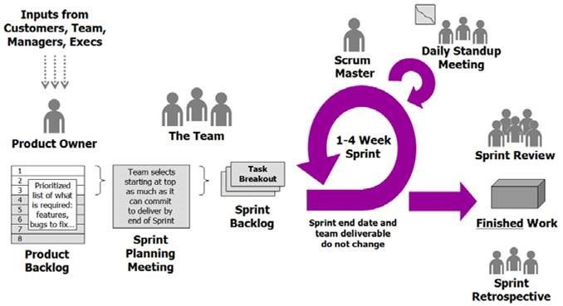Figure shows the SCRUM process

Scrum is an Agile, team-based framework that focuses on iterative and incremental software development, making it a suitable choice for the Eventure Event Management System. **The process starts by collecting input from various stakeholders, including customers, team members, managers, and executives.** These inputs are organized into a prioritized Product Backlog, managed by the Product Owner, who ensures it includes essential features, bug fixes, and updates to support the team's operations (Radigan, 2025).

**During the Sprint Planning Meeting**, the team selects high-priority items from the Product Backlog to create the Sprint Backlog (zoho, 2025). For the Eventure project, the initial Sprint might concentrate on developing the client registration module, event creation functionality, and a basic dashboard (activecollab, 2025 ). The team, under the guidance of the Scrum Master, divides these features into smaller tasks to be completed within a 1–4 week Sprint (Malek, 2023). **The Sprint end date and team deliverables remain fixed**, ensuring focus and accountability.

**Daily Standup Meetings promote continuous progress**, with each team member sharing updates on their work, plans, and any obstacles they face (Malek, 2023). This encourages collaboration and enables quick resolution of issues, such as challenges with the vendor management module. **The Sprint end date and deliverables stay consistent**, maintaining stability throughout the Sprint.

**At the end of the Sprint, a Sprint Review is conducted**, where the team presents the completed features to stakeholders for feedback. This includes demonstrating functional components like client event booking and vendor profile management. **Following the Sprint Review, a Sprint Retrospective takes place**, allowing the team to reflect on successes and areas for improvement (Szmit, 2023). For instance, if unclear requirements caused delays, the team might enhance communication with stakeholders in the next Sprint, fostering continuous improvement and efficiency.

Advantages of Scrum include **improved collaboration through daily standups**, **adaptability to changing requirements**, **continuous enhancement via retrospectives**, and the **incremental delivery of functional** (geeksforgeeks, What is Scrum in Software Development?, 2024). These benefits make Scrum an effective framework for projects like Eventure, enabling teams to respond quickly to stakeholder needs and deliver value iteratively.

However, Scrum also has its drawbacks. It **demands significant team commitment**, which can lead to burnout if not managed properly. The flexibility to accommodate changes can result in **scope creep**, where the project expands beyond its original goals, potentially causing delays or increased costs. Scrum is **most effective with small teams of 5-9 members**, making it less suitable for larger teams that may struggle with coordination and communication (Miseviciute, 2024). Additionally, the focus on delivering working software quickly can lead to **incomplete documentation**, creating challenges for future maintenance or onboarding. Lastly, the success of Scrum heavily depends on the **expertise of the Scrum Master**; if the Scrum Master lacks experience or fails to facilitate effectively, the team's productivity and morale may suffer.

By implementing Scrum, the Eventure project benefits from **structured, iterative development**, **ongoing stakeholder engagement**, and **adaptive planning**. By using SCRUM methodology is ensures that the delivery of a **user-friendly, efficient event management system** that aligns with business objectives while maintaining flexibility to adapt to evolving needs.

# 3.0 System Analysis

Eventure, a highly regarded event planning company in Malaysia, has established itself as a trusted name in organizing a wide range of events, including corporate gatherings, weddings, and private parties. With Samantha’s extensive experience and a strong network of reliable vendors such as decorator, photographer, florist, logistic company and etc. The company has consistently delivered high-quality and memorable events, earning client trust and loyalty in order to build strong and reliable relationship. However, as the business grows, Eventure faces challenges such as manual processes, limited technological infrastructure, and resource constraints, which hinder its ability to scale efficiently. To address these weaknesses and capitalize on opportunities like digital transformation and financial tracking, Eventure is developing an Event Management System. Using a structured Project Analysis approach, the company aims to create a system that enhances operational efficiency, improves client engagement, satisfaction, and ensures long-term success in a competitive industry to strengthen it market position.

## 3.1 Business Intelligence analysis - SWOT

**Strengths:**

One of the Eventure's main strengths is its well-known reputation as well as valuable experience in planning different kinds of events such as gatherings, weddings, and private parties, and the like. Since Samantha has years of hands-on experience in managing event, this makes her very skilled at understanding what clients really need and what challenges may face during the process of event planning.

Furthermore, the next strength is Eventure’s strong network of reliable vendors. Over time, Samantha has built good working relationships with trusted caterers, decorators, photographers, and other service providers. By having these networks, it allows Samantha to easier to find the right vendors and ensures that clients always get high-quality services. For instance, Eventure can offer clients a wide variety of food options through its partnerships with well-known caterers, often at competitive prices. Even better, these trusted connections make it easier for Eventure to deliver well-organized and memorable events.

**Weakness:**

* Manual process: the current system using manually operation is time-wasting and easy to get error. This limits the efficiency of company’s ability to scale and respond quickly to customer demands.
* Limited technological infrastructure: The current system needs to have a more function to integrate and manage all information, manage the client inquiry, even details, and so on. So, the user can easily operate the system with their need.
* Resource Constraints: With a growing client base, Samantha will be hard to manage all aspects of the business alone, which could lead to burnout and declining service quality.

**Opportunities**:

One of the opportunities for Eventure to grow is by introducing an online platform. A website or client portal would make it easy for clients to check available services, confirm event dates, and also book directly online. This feature could attract more people, especially younger clients who prefer using online tools. It would also save time for both clients and staff, as everything could be managed in one place. For example, a couple who are planning their wedding could log into the portal to view updates, contact their planner, and even track their progress all in one convenient location. By having this kind of system, it would help create a smoother and more enjoyable experience for clients.

Eventure could also benefit from adding financial tools to its system. By having these tools, it can help them to track budgets and also provide a insight on how much is spent on each and every event, where giving Samantha a better idea of profit earned. This useful information will help Samantha to decide where should be focussed to improve services.

**Threats:**

* Market Competition: The event planning industry is highly competitive, with great number of businesses offering similar services. If Eventure fails to develop and adapt, it has high possibility to losing its market share to competitors who have more advanced technologies.
* Technological Issues: Transitioning from manual to digital operations presents important challenges, including the need for staff training and the potential for technical issues. These barriers must be carefully managed to ensure a smooth transition.
* Client Expectations: As Eventure employee new technologies, clients will expect a seamless digital experience. This will need continuous system updates and innovation to match their requirement and maintain satisfaction.

## 3.2 System Analysis for Eventure Event Management System: Project Analysis Approach

In the development of the Eventure Event Management System, a structured and thorough approach to system analysis is essential to ensure that the final system aligns with business requirements, enhances operational efficiency, and delivers a seamless experience for both clients and internal users. Among various system analysis methodologies, Project Analysis has been chosen as the primary approach due to its ability to provide a comprehensive assessment of feasibility, scope, risks, and resource allocation for the project. This method ensures that all critical components of the system are strategically evaluated before moving into the design and implementation phases.

Project Analysis is a vital system analysis method that facilitates a holistic evaluation of the project from multiple dimensions. It involves assessing the feasibility, functional requirements, financial constraints, technical considerations, and overall project impact. Given the complexity and multifaceted nature of Eventure’s operations, this method is particularly beneficial in ensuring feasibility, defining the project scope, assessing risks, allocating resources, and validating stakeholder requirements.

A feasibility study is a crucial aspect of Project Analysis as it determines whether the envisioned system is viable within the allocated budget of RM 75,000 and the five-month development timeline. It evaluates technical feasibility by assessing whether the required technology and expertise are available, operational feasibility by analyzing how well the system aligns with business needs, and financial feasibility by considering cost-effectiveness and return on investment.

Defining the scope of the system is another essential component. The system must encompass event management, vendor coordination, financial tracking, client interaction, and automation features. Project Analysis ensures that the scope is well-defined to prevent scope creep, ensuring that deliverables align with Samantha’s expectations and business goals.

Risk assessment is a fundamental part of Project Analysis. Identifying potential risks such as budget overruns, timeline delays, data security concerns, and integration challenges is crucial. This approach enables proactive risk management by proposing mitigation strategies, ensuring that potential roadblocks do not compromise project success.

Resource allocation and task prioritization play a significant role in ensuring the efficiency of the project. Effective distribution of human, technical, and financial resources is imperative. Project Analysis helps identify critical tasks, prioritize system functionalities, and allocate resources effectively to optimize productivity and ensure timely completion.

Validating stakeholder requirements is another essential benefit of Project Analysis. By systematically analyzing collected data, this method ensures that all stakeholders’ needs, including Samantha’s team, vendors, and clients, are accurately translated into system features. This reduces discrepancies and enhances user satisfaction post-deployment.

During the Requirement Elicitation phase, extensive data was gathered through interviews with Samantha and her team, surveys from clients, and consultations with IT specialists. Using Project Analysis, these findings are categorized and examined to draw insights that influence system architecture and functionality. The key areas analyzed include event management, vendor and resource management, client engagement features, and the financial management system.

Through the structured approach of Project Analysis, Eventure’s system development is strategically guided to enhance efficiency, improve client engagement, and establish a scalable digital infrastructure. By conducting a detailed assessment at each phase, this method ensures that the project remains within budget, meets business objectives, and delivers a robust solution that positions Eventure for long-term success in the event planning industry.

Conclusion:

The development of the Eventure Event Management System marks a key step in addressing the company’s operational challenges and leveraging its strengths to stay competitive. Through a integrative of Project Analysis approach, the project has been properly assessed for feasibility, scope, risks and resource allocation. This is to ensures that the system arranged with business objectives to meets stakeholder specifically requirements and stays on budget and timeline. By adding an online platform, using financial tools, and automating key processes, Eventure is well-positioned to improve efficiency, client satisfaction and maintain its market position. The successful implementation of this system is not only resolving current weaknesses but also create a scalable of digital infrastructure, making it easier for long-term growth and success in the ever-changing event planning industry.

# 4.0 Design

## 4.1 Use Case Diagram

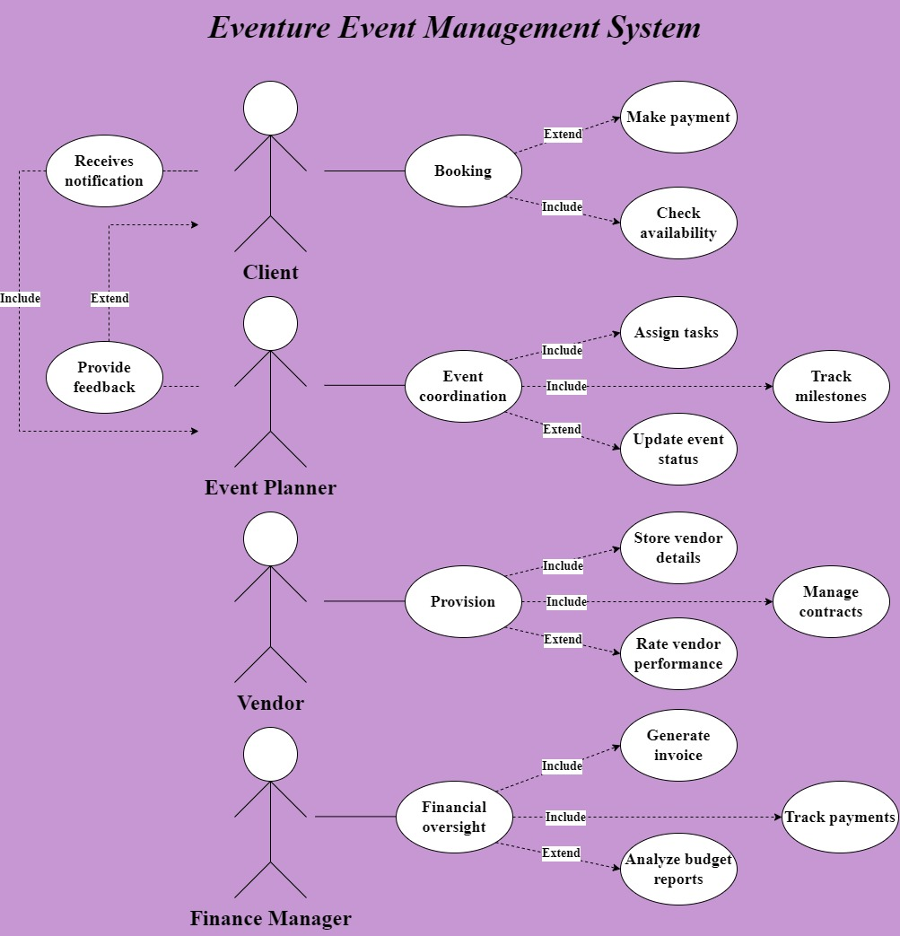

This Use Case Diagram represents the Eventure Event Management System demonstrating the relationship between different users and system functionalities. The Client reserves events, view availability, makes payments, obtains notifications, and provides feedback. The Event Planner coordinates events by assigning tasks, tracking milestones, and updating event status while also receiving client feedback and sending notifications. The Vendor manages service provisions by storing vendor details, handling contracts, and rating vendor performance. The Finance Manager oversees financial aspects, including generating invoices, tracking payments, and analyzing budget reports. The "Include" relationships indicate mandatory steps, while "Extend" relationships highlight optional actions. (Rodina, n.d.) This system streamlines event planning, ensuring efficient coordination, communication, and financial management.

## 4.2 Class Diagram

Ong Kai Ying (TP086065)

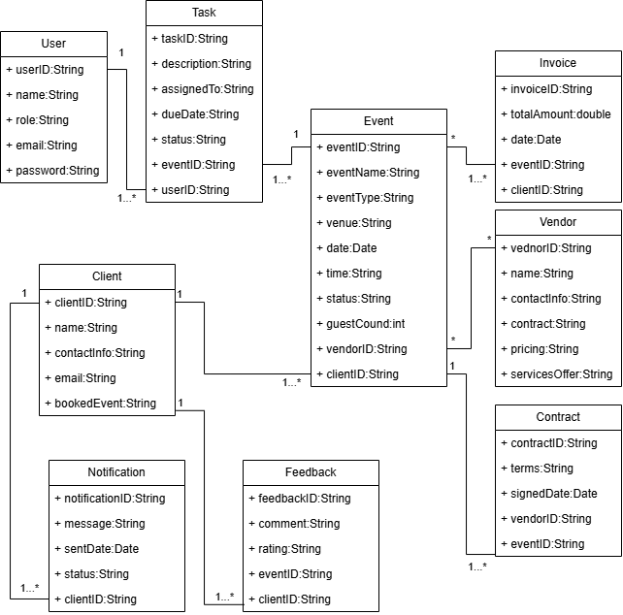

The Client class represents customers that book events, with properties including "clientID", "name", "contactInfo", "email", and "bookedEvents". A client can have many events assigned, which means one-to-many. The Event class records all the details of the event, such as "eventID", "eventName", "eventType", "venue", "date", "time", "guestCount", "status", "budget", "tasks" and "vendors". Each event has belonged to one client but can have many tasks, and multiple vendors associated with them, creating one-to-many and many-to-many relationships.

The Task class defines a specific task with "taskID", "description", "assignedTo", "dueDate", and "status". Each task belongs with one event, it is a many-to-one relationship. The Vendor class models an external service provider such as catering or photography, with "vendorID", "name", "contactInfo", "servicesOffered", "pricing", "contracts", and "ratings", can serve multiple events, creating a many-to-many relationship. The Contract class formalizes agreements between vendors and events, with "contractID", "vendor", "event", "terms", and "signedDate", is a many-to-one relationship with events and a many-to-one relationship with vendors.

The Invoice class deals with the financial aspects of an event with "invoiceID", "event", "client", "totalAmount", "amountPaid", "balanceDue", and "dueDate". An event can have multiple invoices, this is a one-to-many relation. The User class captures attributes of event planners and administrators with "userID", "name", "role", "email", and "password". The Notification class with records messages being sent to the client or user, include "notificationID", "recipient", "message", "sentDate", and "status", establishing a one-to-many relationship as a recipient can have multiple notifications. Finally, the last class, Feedback, records the reviews given by a client for an event with "feedbackID", "event", "client", "comments", and "rating". Another one-to-many relationship exists where each client can leave feedback for multiple events.

To summarize, this system combines clients, events, tasks, vendors, finances, and communications for a seamless flow of planning and execution of an event.

## 4.3 State Machine Diagram

Tee Ching Ying (TP072694)

The modelling diagram that used to indicate the situation of a system or portion of the system at specific instances of time is a state diagram. A state diagram contains states, events, guards, transitions, and actions. This diagram can also be calling as behavioural diagram or state machine diagram, it indicates the behaviour using limited state transitions. Based on the present situation, an object gives feedback to the same event differently. Although there is typically used for objects, state diagrams can be used for all component that indicates behaviour toward other entities, including methods, use cases, actors, systems and subsystems. Sequence diagrams are usually used in combination with them. (GeeksforGeeks, 2025) (baeldung, 2024) (visual Paradigm)

**STATE**

A state is a situation or limitation where the object waits for an event to happen or acts while the constraint is in existence. It explains condition or phase of the system. An object or system can be viewed as moving from state to state. The name of the state is written inside a rounded rectangle that represents the state. (GeeksforGeeks, 2025) (baeldung, 2024)

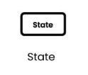

**INITIAL STATE AND FINAL STATE**

There is an initial state and final state needed in during create the system diagram. The initial state also equals as initial pseudo-state that represent by filled circle as the starting point of the system. As a system's end point, the final state was shown as a colour circle inside a circle notation. An object in a closed loop state diagram doesn't have a final state. If it does, the object continues until the system terminates. An entity that might end before the system does is shown by an open loop state machine. (GeeksforGeeks, 2025) (baeldung, 2024)

 

**TRANSITION**

A transition is the process that transfer the information from one state to another. The event that triggers the transition is indicated by a label on each transition line. The transfer or shift of process from one state to another is symbolized by an arrow. System analysis and design include an understanding of state transitions, which is helpful for interpreting complex behaviours. The event that triggers the transition, a condition that must be satisfied for the transition to occur, and an action statement that will follow the change are the three indications of this process. When distinct events cause a state to end, or when the transitions happen due to guard conditions, multiple transitions take place. Automatic transitions refer to those that don't involve an event or an action. (GeeksforGeeks, 2025) (baeldung, 2024) (visual Paradigm)

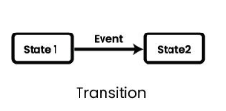

**FORK STATE AND JOIN STATE**

Fork and join states are usually used in systems with concurrency. A fork state with one incoming arrow and several outgoing arrows leading to each thread is established ahead to the concurrent threads being generated. A join state that joins several arrows from each thread into a single arrow placed after the concurrent threads. Automatic transitions refer to those that don't involve an event or an action. A rounded, solid rectangular bar with input arrows from parent state and output arrows pointing to another states is used as a sign of a fork notation. The solid rectangular bar also represents join notation with outgoing arrows towards common destination state and incoming arrows from the connecting states. (GeeksforGeeks, 2025) (baeldung, 2024)

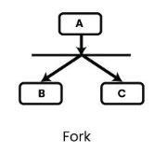 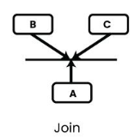

**COMPOSITE STATE AND SELF TRANSITION**

Composite state is form by using rounded rectangle. It illustrates the state with internal activities which is states that have sub-states. A composite state may not necessarily begin at the initial state and can have a different entry point. Besides that, it may also not necessarily end at the final state and can have a different exit point. The concurrent states are sub-states of a composite state that are executed concurrently. (GeeksforGeeks, 2025) (baeldung, 2024)

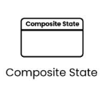

**CHOICE STATE**

A diamond with one arrow entering and several arrows departing the state is used to symbolize the choosing state. It displays a system decision point where each outgoing arrow has a condition written on it that determines the outcome. The diagram below is the example of the choice state. (baeldung, 2024)

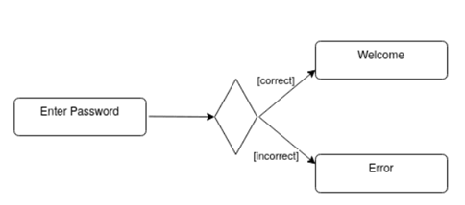

**EVENTS**

Incidents that result in objects changing states are represented by events. Events that occur internally or externally cause some activity that modifies the system's and some of its components' states. Information is passed by events and developed by Objects operations. Design involves looking at state machine diagram events and finding out how system objects will support such events. An event may be a signal or a shift in the system's surroundings. The state of the system could vary as a result of events. There are four different kinds of events. For example, signal events which happen when an asynchronous message or signal arrives. The time events which take place after a certain period has passed. The call events that develop when a process call to an operation arrives and the change events will occur whenever a certain condition is satisfied. (baeldung, 2024) (visual Paradigm)

**ACTION**

Specific functions that the system invokes are called actions. The states are able to initiate and take action. Actions or activities carried out when an entity is in a state can be classified as a second compartment of a state. Entry activities, do actions, and exit actions are the three categories of state actions. The functions that are called after a transition is complete are known as the transition action. Since an action is an atomic execution, it ends without a break. (baeldung, 2024) (visual Paradigm)

**State diagram of Eventure Project**

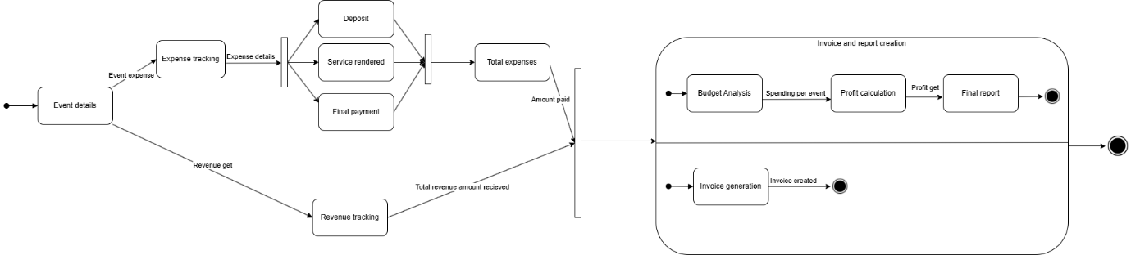

## 4.4 Activity Diagram

Lau Jie Yin Alfy (TP070026) 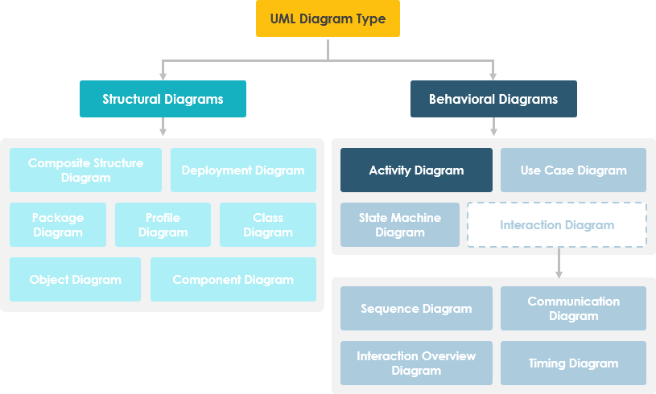

Figure above shows what is activity diagram (visual-paradigm, 2024)

An **Activity Diagram** in UML (Unified Modeling Language) is a **Behavioral Diagram** that visualizes the flow of activities or processes within a system, similar to a flowchart. It depicts the sequence of actions and control flow between them. Key components include **Activities** (rounded rectangles for tasks), **Transitions** (arrows showing flow), **Decisions** (diamonds for branching paths), **Start/End Nodes** (circles indicating process boundaries), and **Swimlanes** (to assign tasks to specific actors). These diagrams are useful for modeling workflows, business processes, and system logic, aiding in identifying inefficiencies and improving processes.

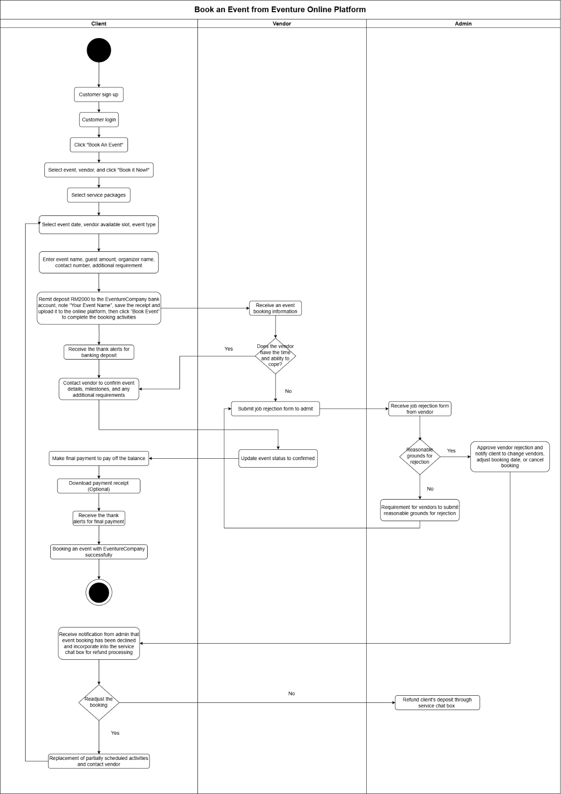

Figure shows the activity diagram of client book an event via Eventure online platform

**For the Eventure project, a highly effective modeling technique to employ is the Activity Diagram from the Unified Modeling Language (UML).** Activity diagrams are very useful for showing out the workflow of activities and actions through a system (geeksforgeeks, Activity Diagrams – Unified Modeling Language (UML), 2025). They are a great option for explaining the Eventure platform's event booking procedure since they provide a clear visual depiction of the workflow.

**The client, vendor, and administrator's steps during the event booking process would be demonstrated clearly by the activity diagram.** The process begins when the client decides to book an event via Eventure Management System. Firstly, the client needs to sign up or login into the platform. After logging in, the client is able to select the "Book an Event" option. Moreover, this is followed by choosing an event, selecting a vendor, and picking appropriate service packages. The client also needs to select the event date, verify vendor availability, and specify the event type. Subsequently, the client is requested to provide detailed event information, such as the event name, guest count, organizer name, contact number, and any additional requirements to let vendor know clearly.

**A decision node is incorporated to verify if the event deposit has been made.** If the deposit is made, it is compulsory for the client to upload the receipt to the platform. If the deposit is not made, the process pauses until the deposit is complete banking. Once the deposit is confirmed, the vendor will receive the booking information and checks for any scheduling conflicts, enough manpower, or any other issues. Then, the vendor will contact the client to confirm the event details and discuss any additional requirements.

**After the vendor confirms the details, the client proceeds to make the final payment.** Upon completion of the final payment, the client’s event is successfully booked. Notifications are sent to all parties involved, including the client, vendor, and admin, to confirm the booking. Besides that, the status will be updated to confirm the booking. If the booking is cancelled, the vendor should submit the reason of job rejection to admin. Once the admin approved the rejection reason, the client will receive notification to change event details, vendor selection, or cancel booking. Lastly, the client is able to receive the deposit refund through Eventure services chat box.

**Tools such as Draw.io can be used to create the activity diagram.** The diagram should include a section defining the responsibilities for client, vendor, and admin. Actions are represented by rounded rectangles, decisions using diamonds, and start and end nodes using circles. This organized method can ensure clear visualization of the event booking process.

**This diagram will help stakeholders to easily understand the flow of event booking process and identifying possible issues or areas for improvement.**  By giving a clear and detailed representation of every step, the activity diagram makes sure that all people involved have an integration of understanding for the process, improve more smoother of operation and better communication.

## 4.5 Sequence Diagram

Kate Lim Jia Yee (TP070517)

A class sequence diagram is one of the types of diagrams used in object-oriented design. Many people will use this diagram to show how objects interact in a sequential order. By using this type of diagram, it helps us to better highlights the sequence of messages exchanged between objects in order to complete a particular task or process. The reason why we are using this diagram is because they offer a clear and detailed visualization of the interactions between objects or components in a system. One of the biggest purposes of sequence diagram is to depict the communication among objects inside a partnership that carries out a specific task. (Paradigm, 2019)

Then, the first importance of sequence diagram is it provides a clear and better visual representation and detect problems early that can improve design meetings. By detecting problem early, they can ensure efficient troubleshooting and debugging. Furthermore, the next important of this sequence diagram is it helps in documenting the system which makes the system more consistent and easier for teams to maintain it. (Wisbey, 2023)

In this diagram, vertical lines represent different objects or classes that involved in one task, while horizontal arrows represent the messages or actions sent between them. Thus, sequence diagram is a very useful diagram as it allows us to understand how different components in a system work together to achieve a specific goal.

The first step of building a sequence diagram is we need to first choose a specific scenario or process that we want to create then list down the participants that involved in this system. Each participant is represented using a vertical dashed line which named "lifeline" that used to show how long they are involved in that interaction.

After determining the participants involved, we need to add activation bars on the lifeline is to indicate that a participant is active or performing a task. Then, a solid arrows or dashed arrows is used to show the messages that are passed between the participants. (Creately, 2022) For example, when a participant sends a response, we can use a dashed arrow to show the return message.

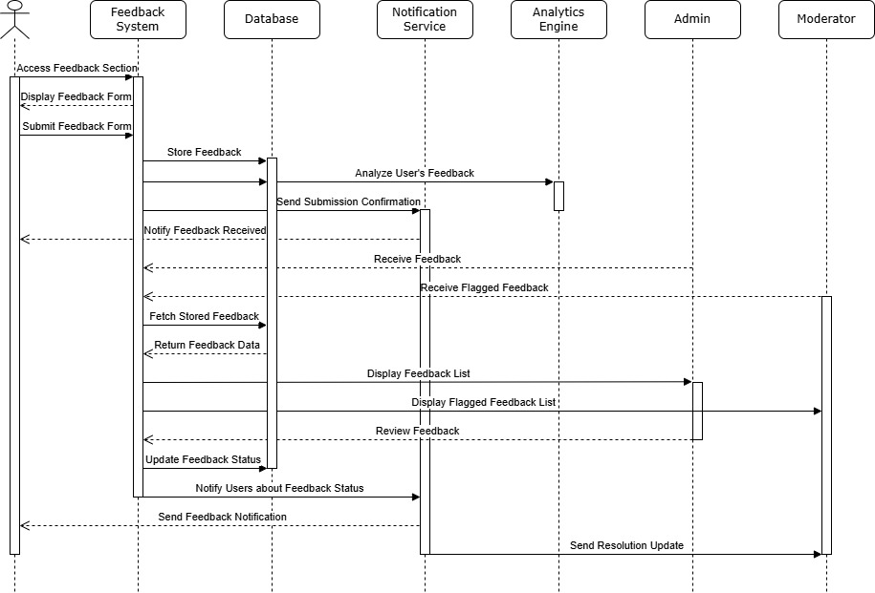

This UML diagram shows how a feedback system works and how different people and services interact with it. Firstly, the user will go to the feedback section of the system, and they need fill out a form to give their feedback. After submitting the feedback, the system stores it in a database and sends to an analytics engine in order to analyse the feedback trends. At the meantime, our notification service will send a confirmation to the user for letting them know their feedback was received successfully.

Next, the database will send this feedback form to admin and moderator, they play an important role as they can access the system to check user’s feedback. For instance, admin can view all feedback submitted by user, while moderator can only see feedback that has been flagged for review.

After a decision is made, the system will immediately update the status of their feedback in the database and the notification service will informs the user about their feedback status. By doing this, the system makes sure each feedback is handled properly, and everyone involved is kept informed.

# 5.0 Implementation and Deployment

## 5.1 Construction Tools

To implement this project, here are some useful software tools that can be used to ensure this system is efficient and user-friendly.

1. Microsoft Visual Studio

Visual Studio provides user a wide range of programming languages including Java, Python, and the like which is an ideal tool in for developers working with different language. Microsoft Visual Studio is also a very useful for Eventure system since it requires a detailed and structured system to manage events, store client details, and the like. (Mir, 2023)

2. MySQL

MySQL plays an important role in data storing because it is more suitable to be used to store and manage a big volume of data such as event information, client data and the like compared to other software tools. MySQL also help in maintaining structured and efficient data management for Eventure, because it can handle complex queries and work with multiple programming languages. (Vyas, 2023)

3. Trello

When it comes to task management, Trella can be used by Eventure for tracking and assigning tasks for the team. This is because Trello offers essential features such as task assignment, progress tracking, and so on which are important in ensuring that all event-related activities get completed on time.

4.Microsoft Teams

Microsoft Teams can be used to facilitate communication among the Eventure team members, which can greatly ensure smooth collaboration. This application is a comprehensive communication platform that allows team members to interact through chat, video calls, and even file sharing.

5. HubSpot

This platform helps system to save precious time as well as increase efficiency via its automation notifications and client communication. It also helps Eventure’s team better understanding the target customer and customer’s behaviours so that they can improve client support. (Shimange, 2023)

## 5.2 Proof of Concept

Prototype of Eventure online platform (Figma Design):

<https://www.figma.com/design/gCTaVrSB9msGuc1MxzRPiw/SDM?node-id=0-1&t=Uy6OY6Y8zHrBDGbz-1>

Customer:



This is the first page of Eventure Management System that all users will see when enter the page.

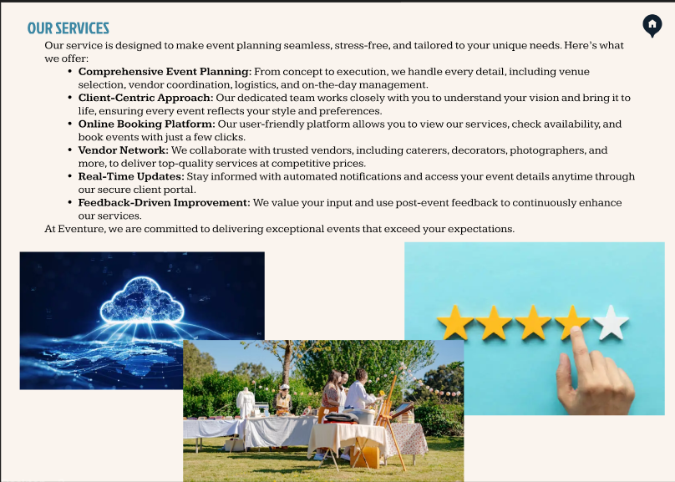

This page will be shown if the user chooses the “Our Service” selection.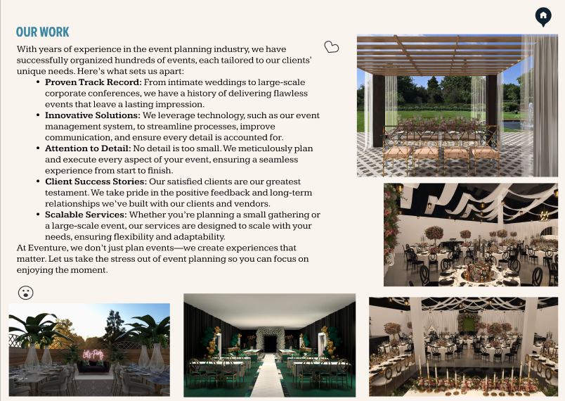

“Our work” page is different with “Our Services” which introduce the event that had done by our company.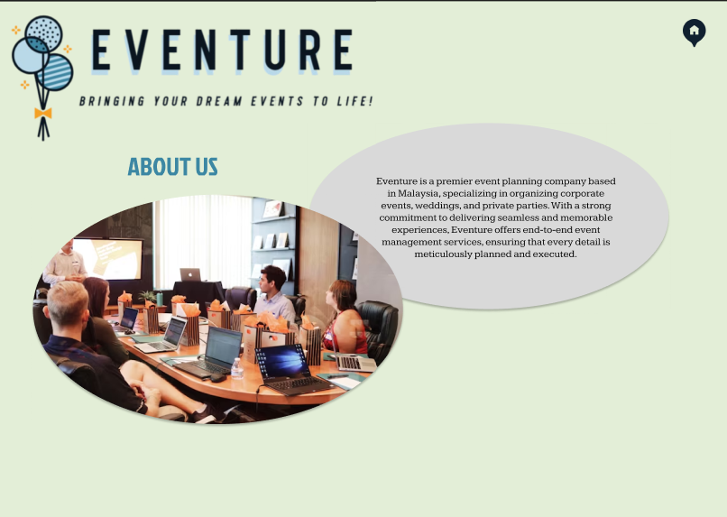There is a short paragraph introduce about our company at “About Us” page.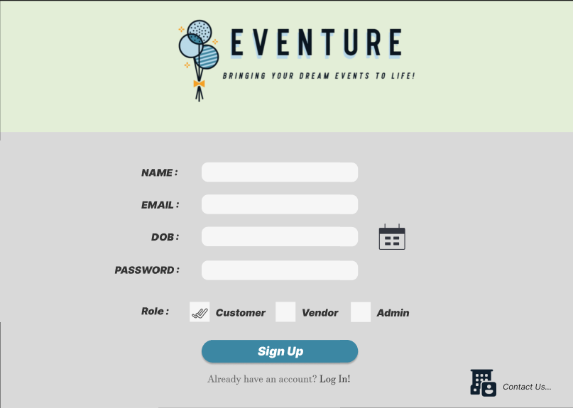

If user didn’t have an account and choose to sign up, they will bring to this page.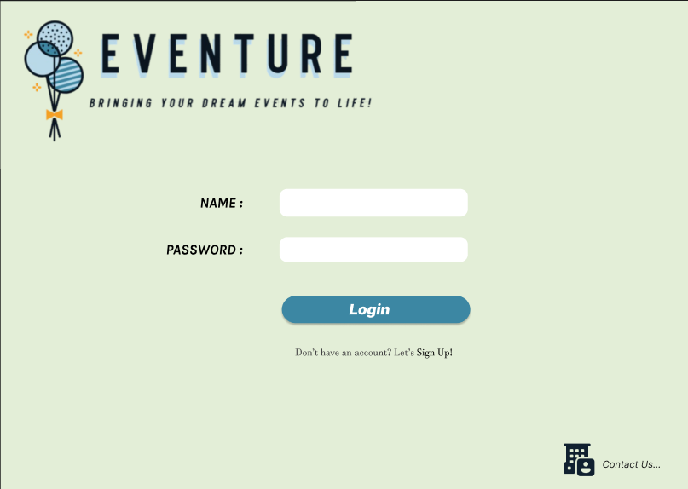The user can log in their account at this page. If user choose the contact us icon at the right bottom, they will bring to “Contact Us” page.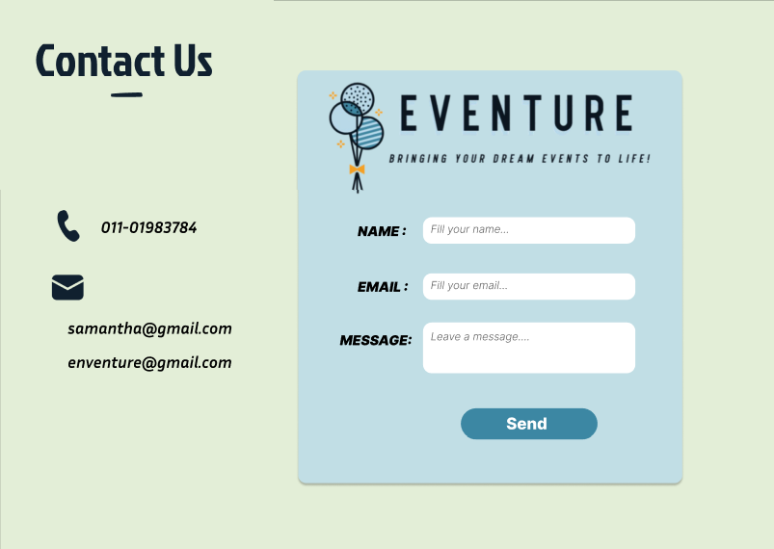

This page contains phone number and email of the company, and the customer can send a message to us. 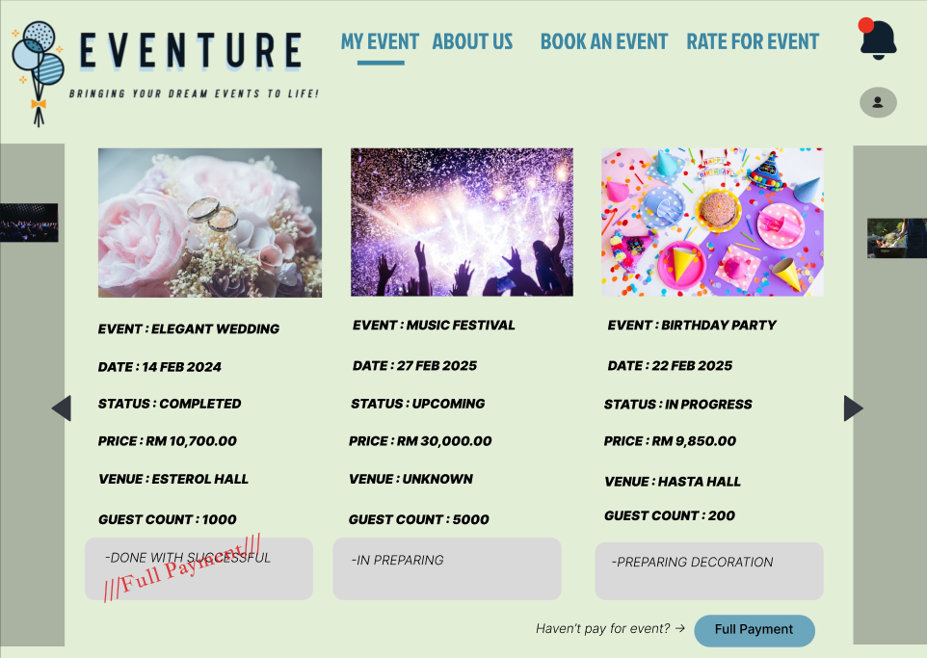

When customer log in successfully, they can see this main page which is “My Event”. In this page, customer can see the event booked together with the event details such as event name, date, status, price, venue and customer count. There will be a red colour label indicate the full payment was done at the bellow of the event details. The current status details of the event also have been indicated at the lower part of event details. To make the full payment, the customer can click the “Full payment” button.

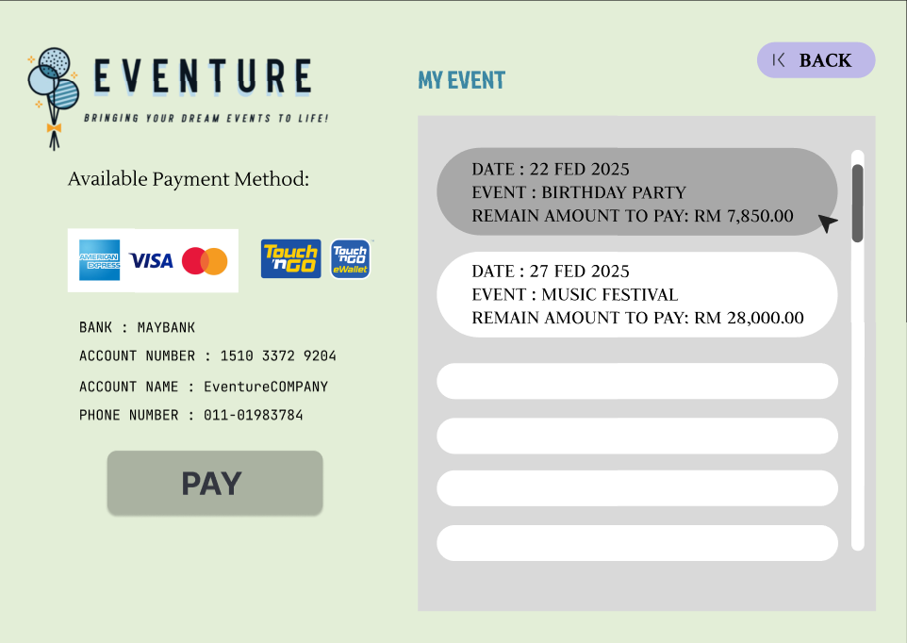

After the button clicked, the customer will bring to this page. They can select the event that they want to make the full payment form the event list at the right side then click the “Pay” button. 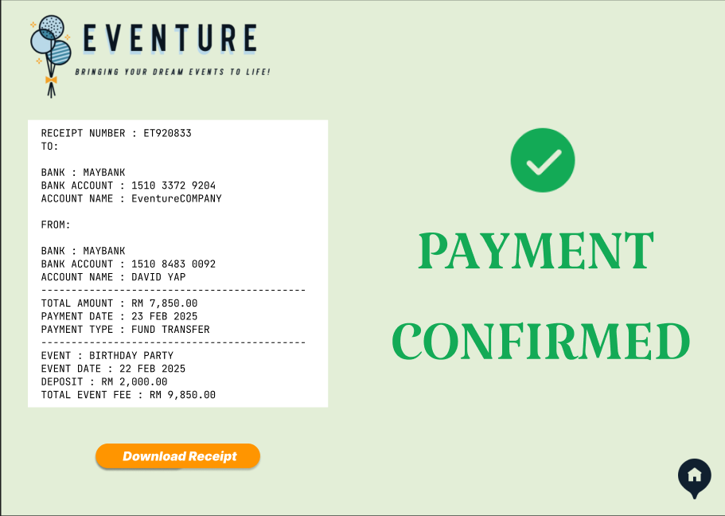

After the payment, the receipt page will be show to customer. They can download the receipt and click the home icon to back to main page.

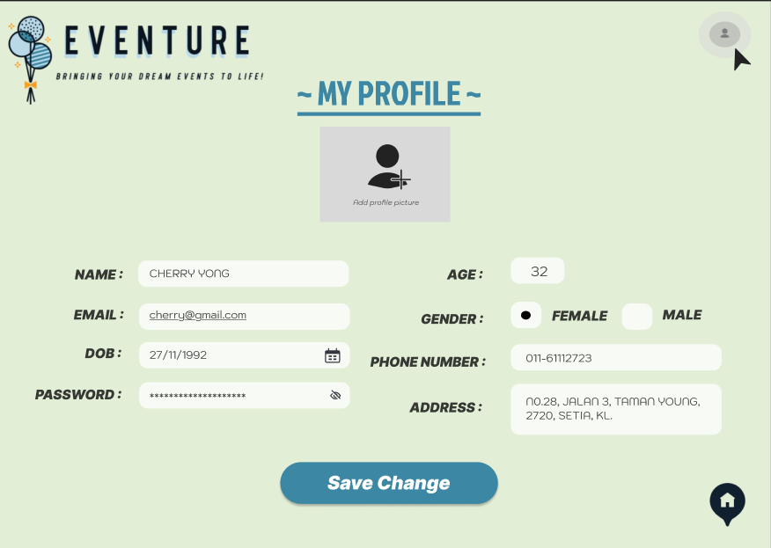

The customer can click the person icon at the above to see their profile and made change.

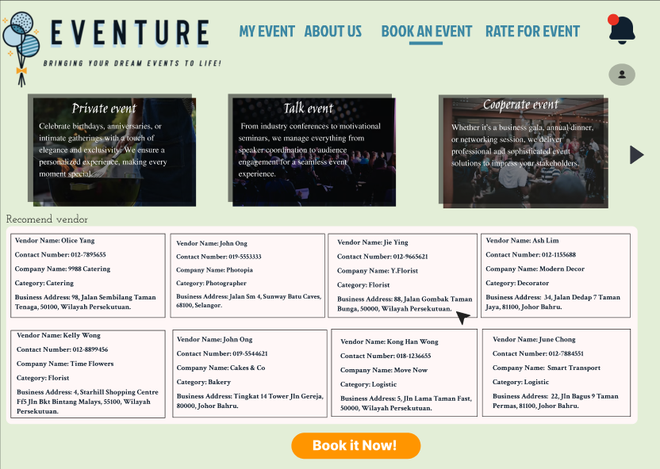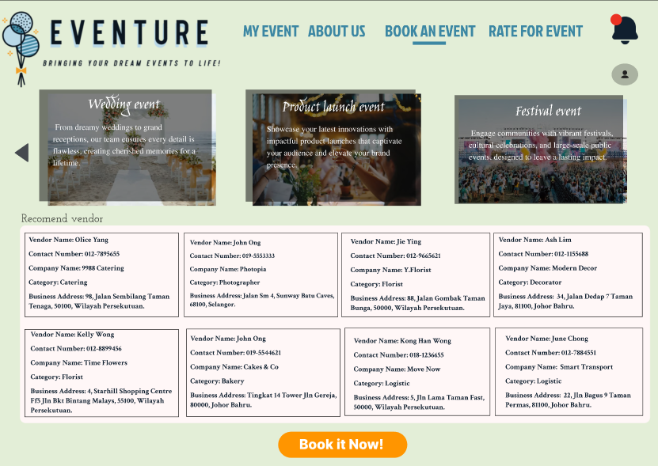

When user choose “Book an Event” page, they can see the event type that our company provide, and the vendor recommend by our company according to vendor performance. Customer can click “Book it Now” button to make a booking.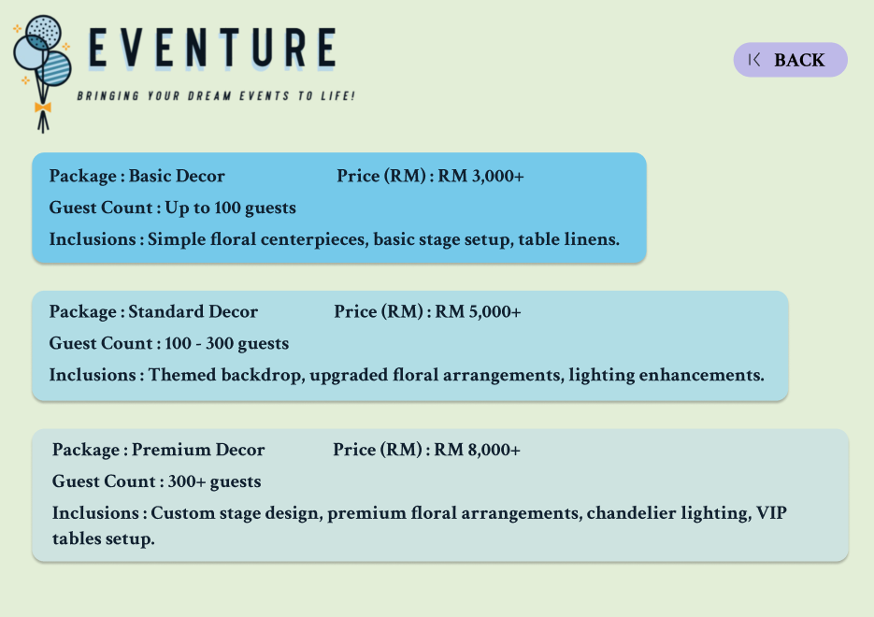

During “Book an Event” page, when customer click the vendor information, they can check the package that the vendor provides and click “Back” button to the origin page after they see the details.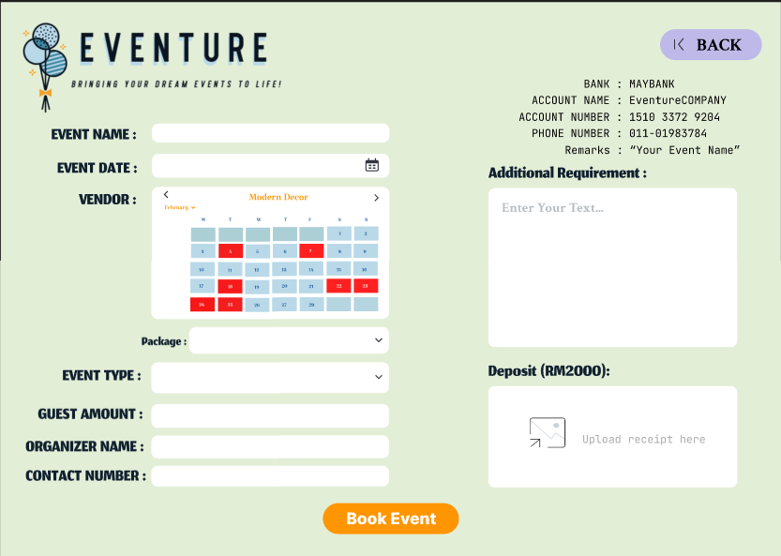

After customer clicked “Book It Now”, this page will be shown, and they need to key in their event information and choose the vendor. The availability of the vendor is shown by the colour in the calendar. The red colour indicate that the vendor is not available at that day. The customer also needs to pay a RM 2000 deposit and upload the receipt then click “Book Event” button to send appointment to vendor. 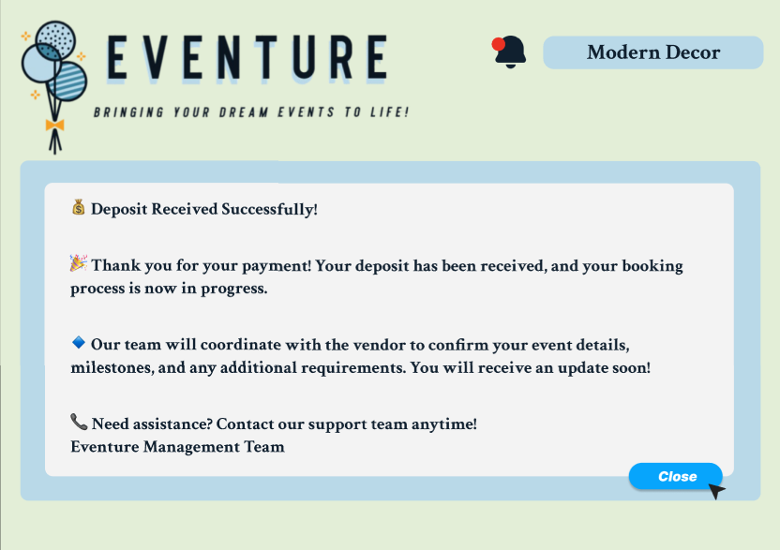

This message will pop up to customer after deposit payment was confirm.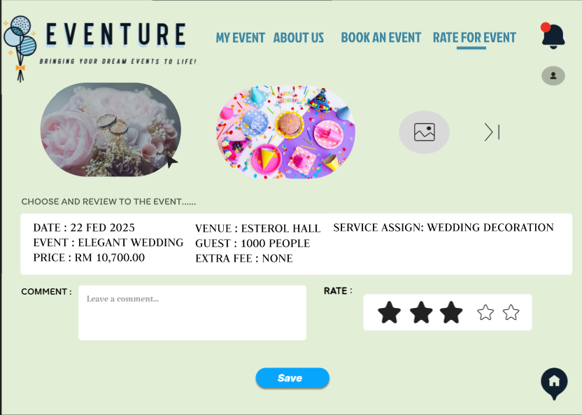

User can click “Rate for Event” page to see their event detail by select the event picture and leave a comment and rate to the satisfaction to that event.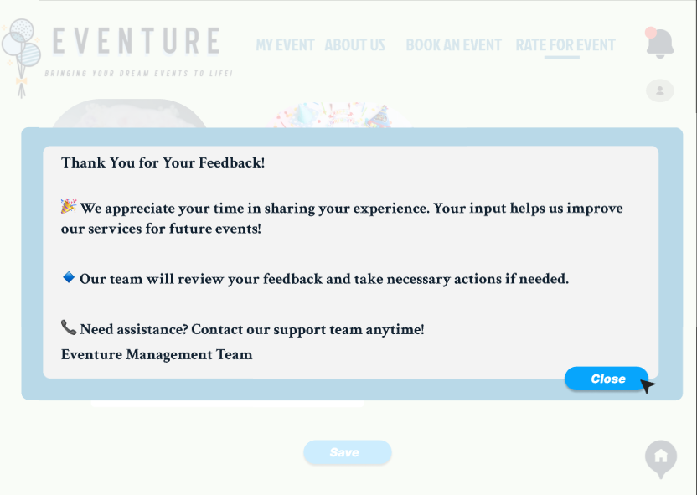After clicking “Save” button, this message will pop up to show to customers. 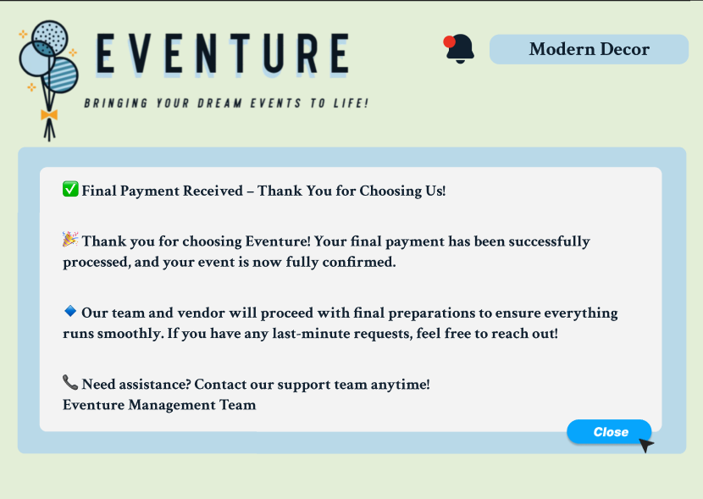 Diagram above is the message that customers will receive after their full payment was check and confirm by admin.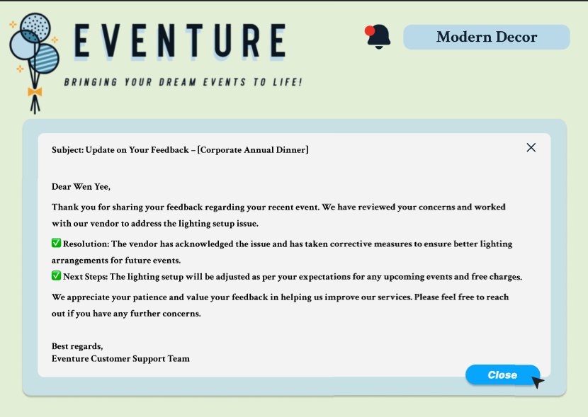

The diagram above is the massage that send to customer when the update of event according customers feedback is done.

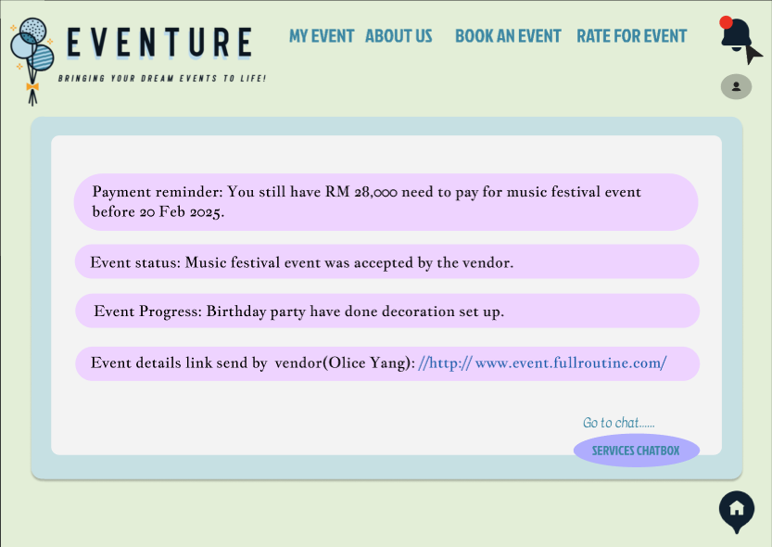

There is a “bell” shape icon located at upper right of the page is a notification. Customers can check any notification from vendor or admin. They can also click the “Service Chat Box” button to go to chat with vendor. 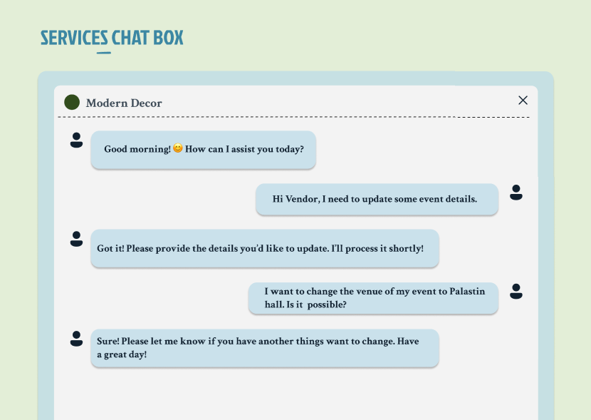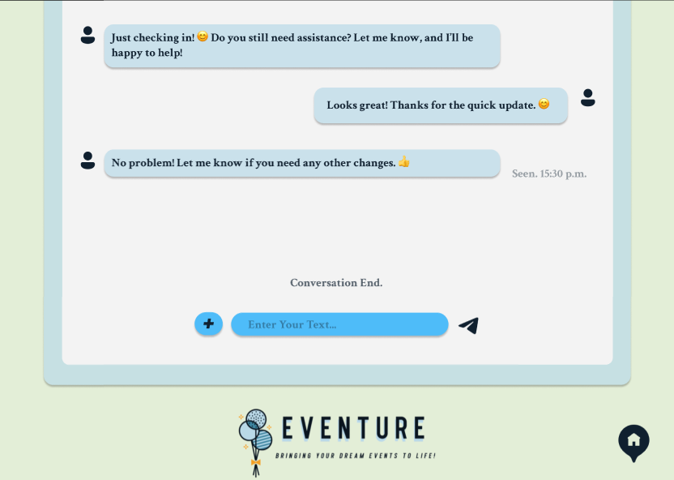

Here are the chat box of the customer and the vendor.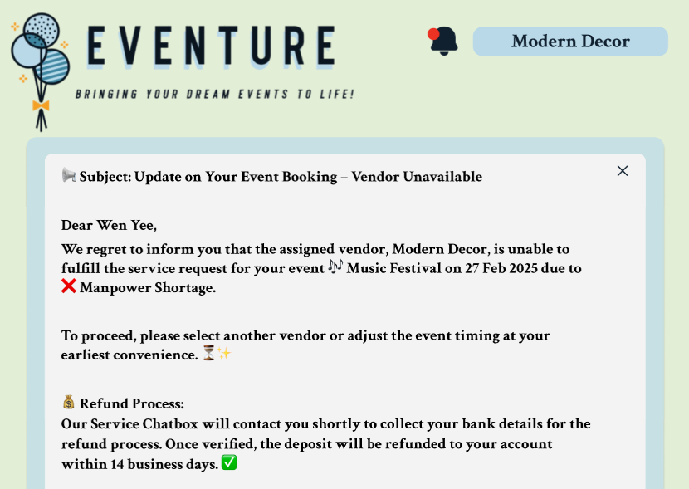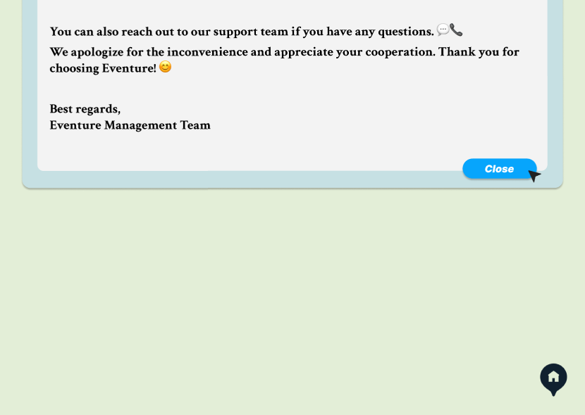

This is a notify message send by admin when the vendor assigned in not available.

Financial Department:

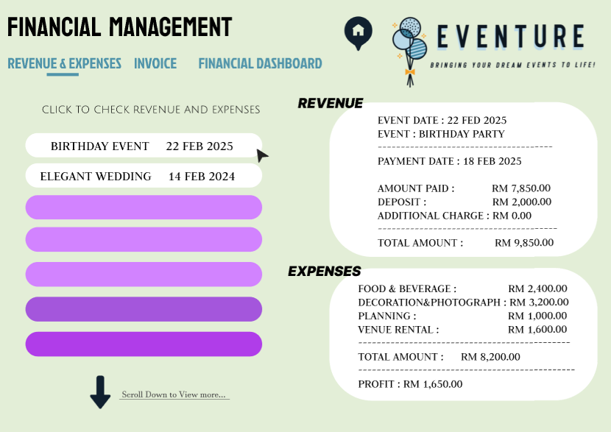

The staff of financial department can login and check the revenue and expenses of every events.

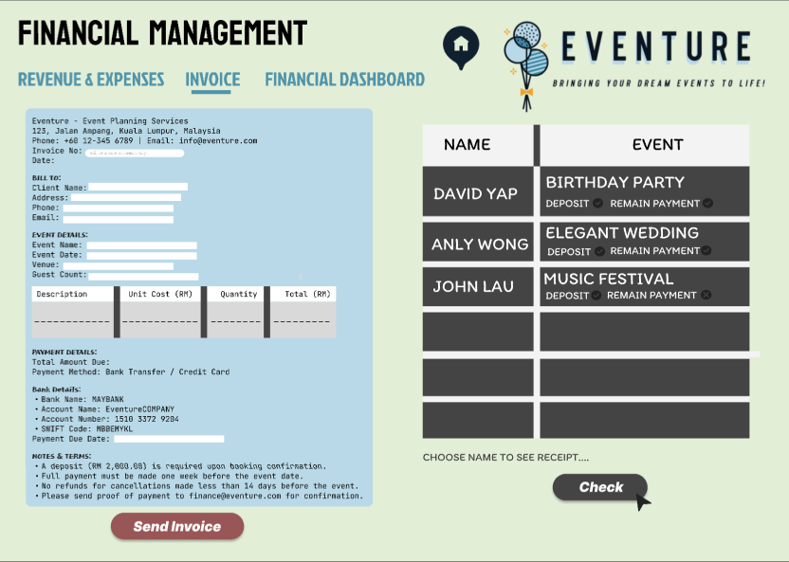

The staff can go to invoice page to fill in the event and expenses detail to send the invoice to customers. The table at the right side is the list of payment from customers. They can select and check the of customer name to see their receipt. 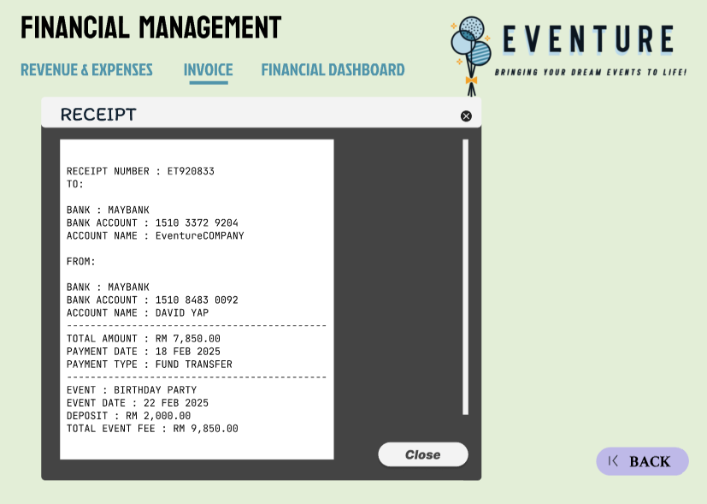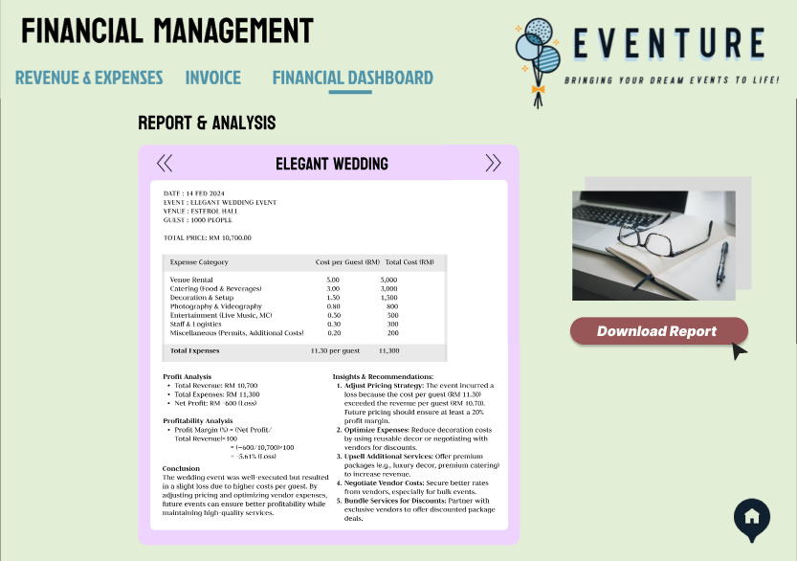

To get the financial report, the staff can go to “Financial Dashboard” page to download

Vendor:

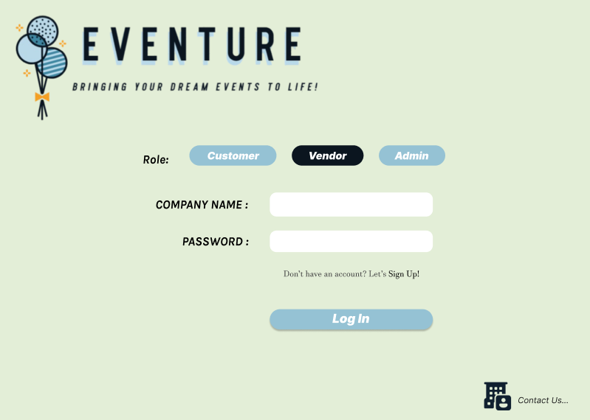

This is the log in page for vendor log in into the Eventure system before starting using the system.

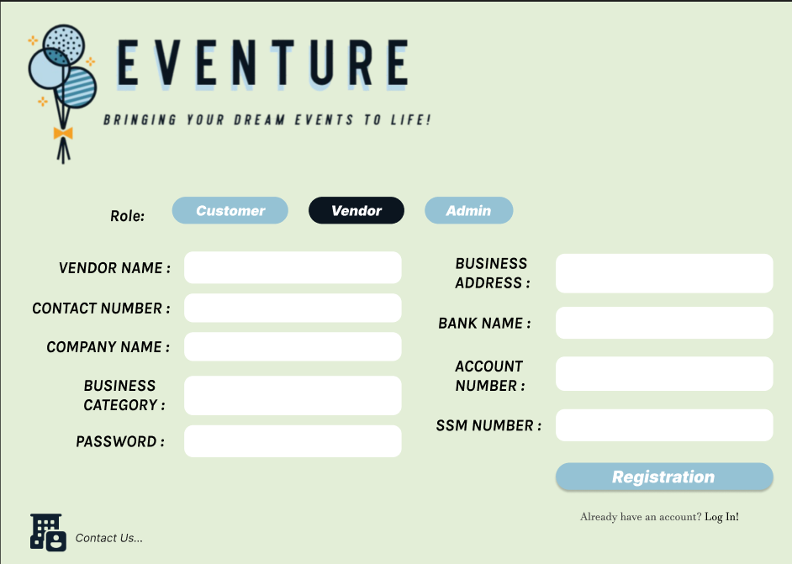

If the vendor did not have the account, they can register by their own. After the admin accepted the request of the vendor registration, the vendor can now get access to the system.

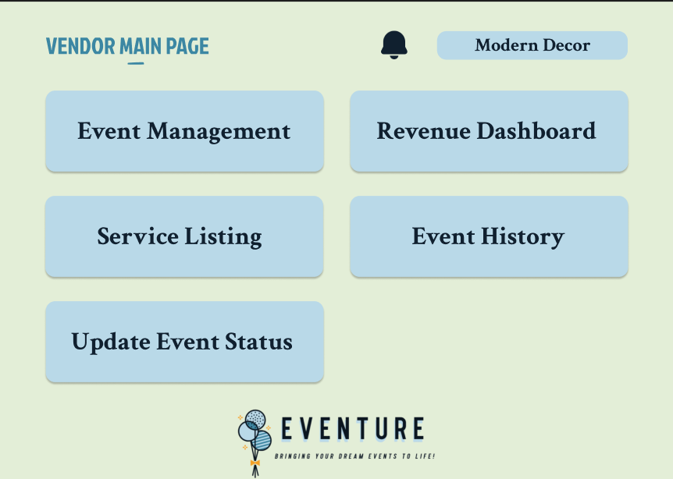

After log in successful, will gain into this page. This page allows vendor to select which task they wanted to perform.

Service Listing:

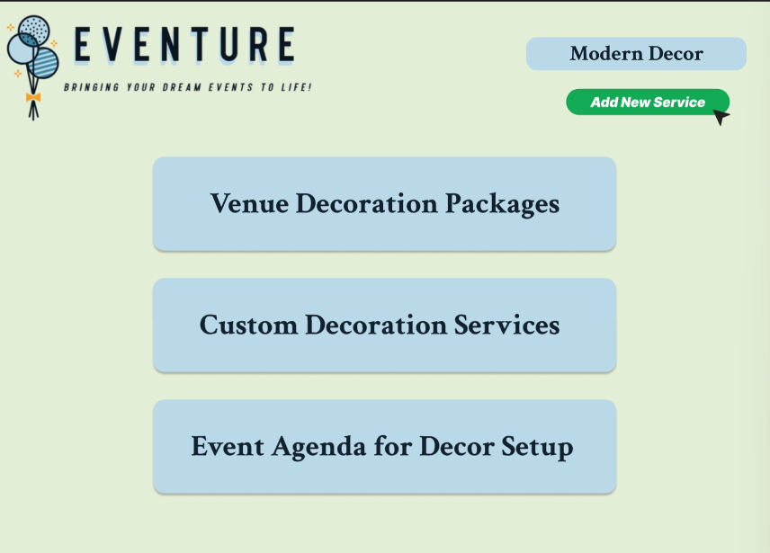

Vendor can select which page they want to view. “Venue Decoration Packages” allow vendors to packages that provides by Eventure company. “Customer Decoration Services” view on the decoration services and “Event Agenda for Deco setup” allow to view for the event agenda.

Venue Decoration Packages:

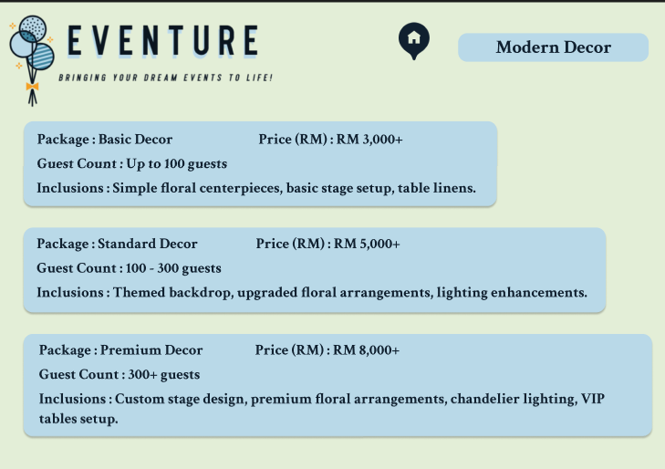

Customer Decoration Services:

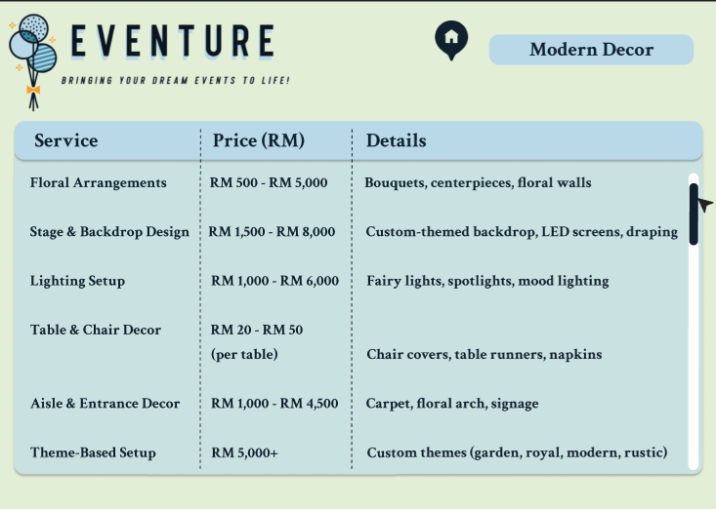

Event Agenda for Deco setup:

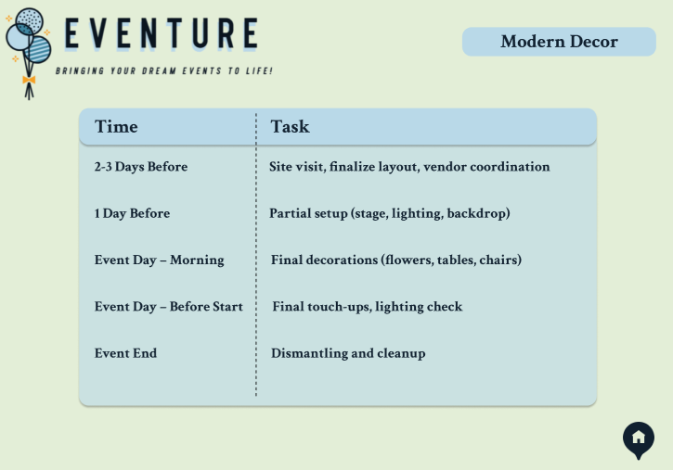

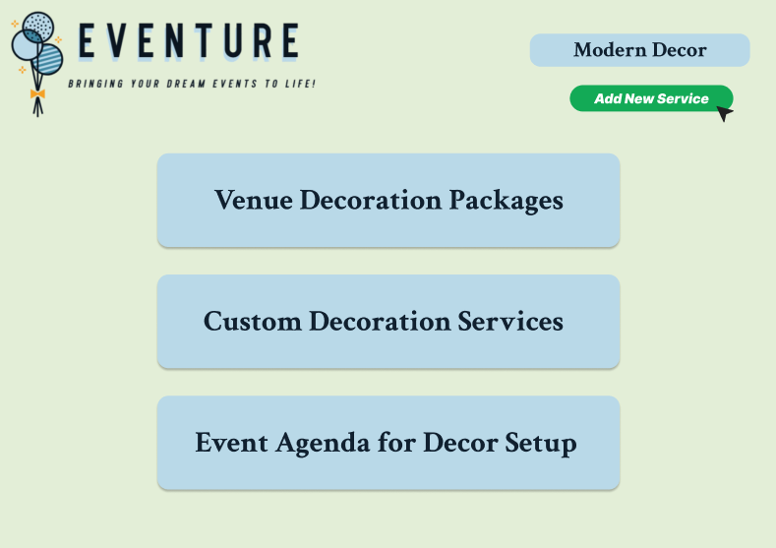 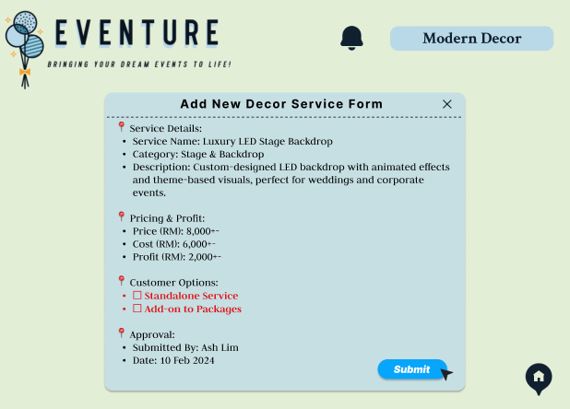

If the vendor selects “Add New Service”, vendor can need for new decoration service. They need to fill in the form and submit to admin. Admin will later update the vendor whether their request of add new decoration services is approved by admin.

Revenue Dashboard:

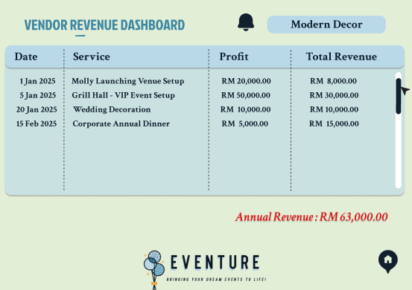

This page allow vendor to view on the revenue dashboard. They can refer all service, date, profit for each service and annual revenue.

Update event status:

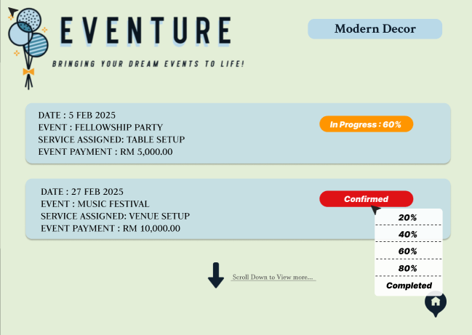

This page allows user update event status whether is in progress or completed.

Review Task History:

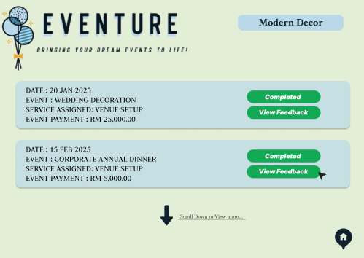

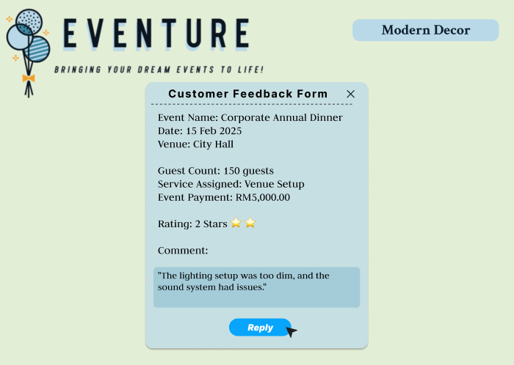

After event is completed, they are allowed to view the feedback from the customer.

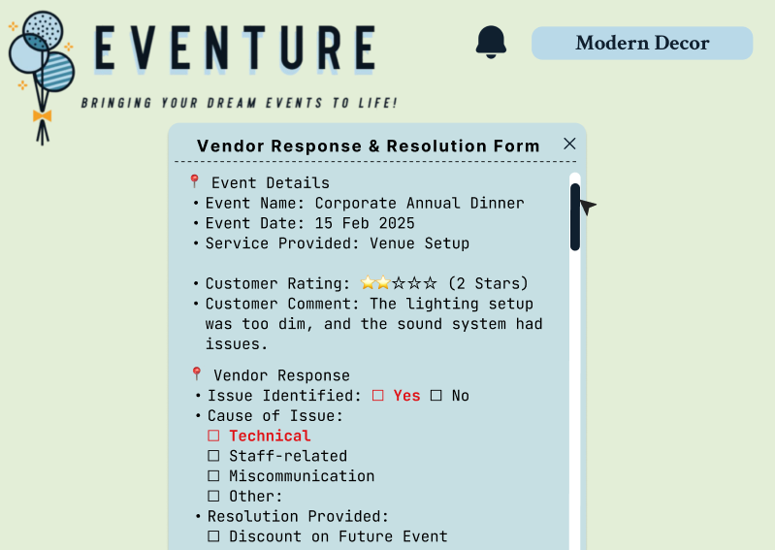

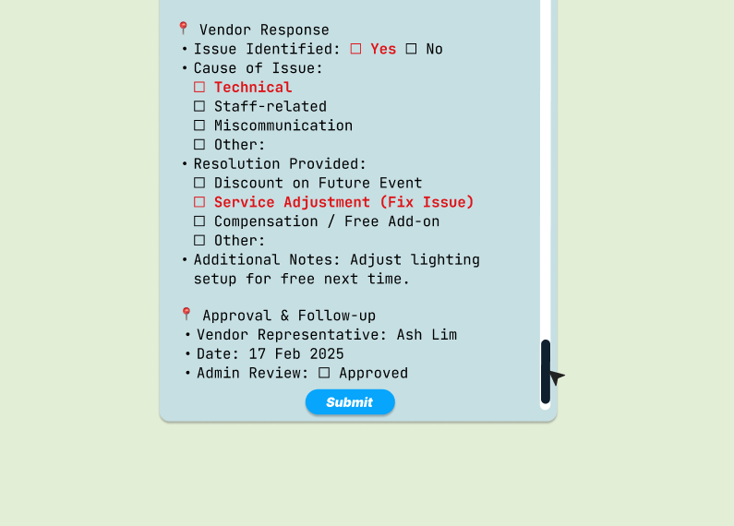

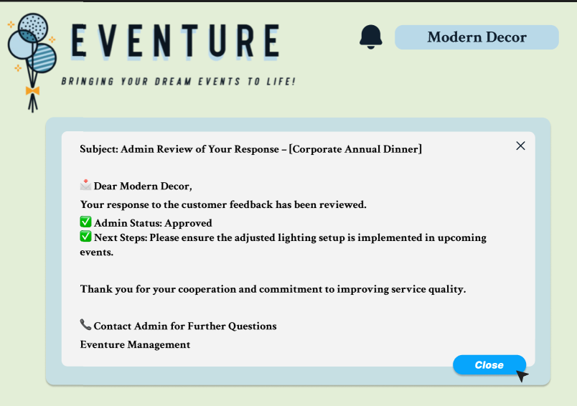

If the customer provides bad comment, vendor need to fill in the “Vendor Response & Resolution Form”, explain the reason and provide the resolution to admin.

Admin:

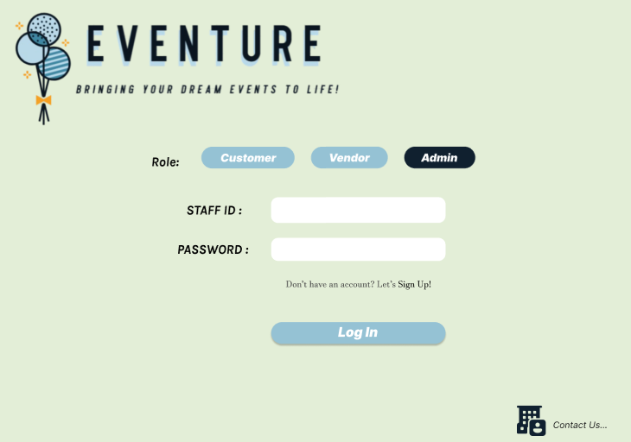This is the log in page for vendor log in into the Eventure system before starting using the system.

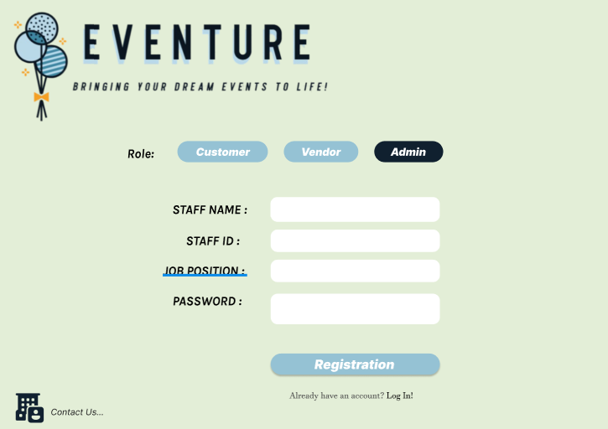

Admin can help new staff to register the account by using their name, staff id, job position and entering password.

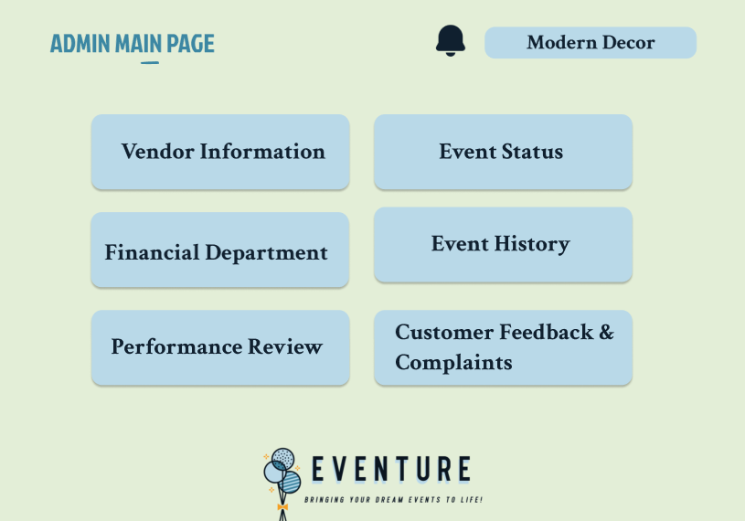

After admin log in, system will jump into this page which is allow admin to choose task they wanted to gain access.

Event History , Event Status ,Customer Feedback & Complaints:

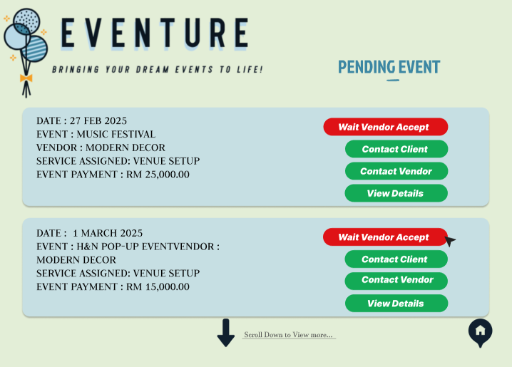

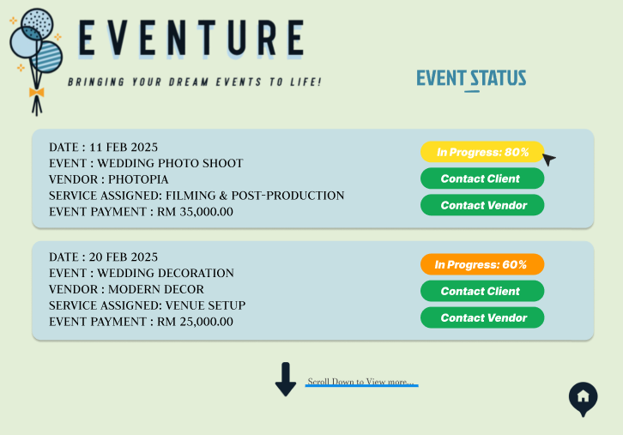

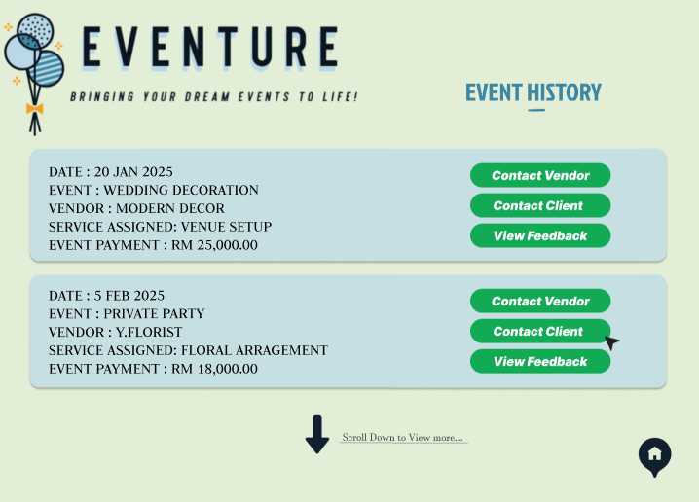

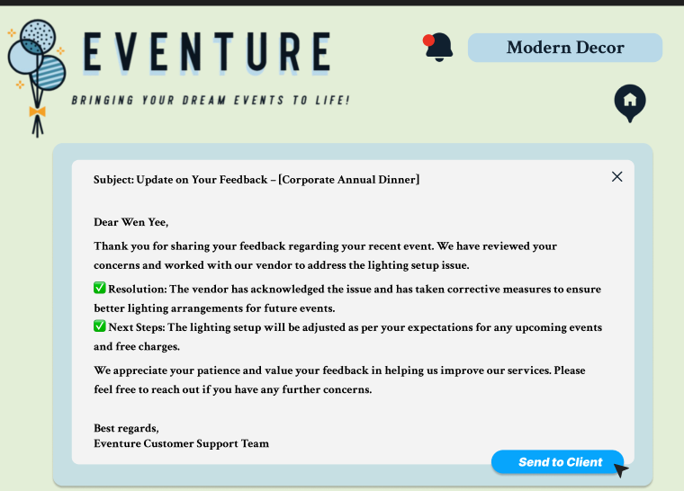

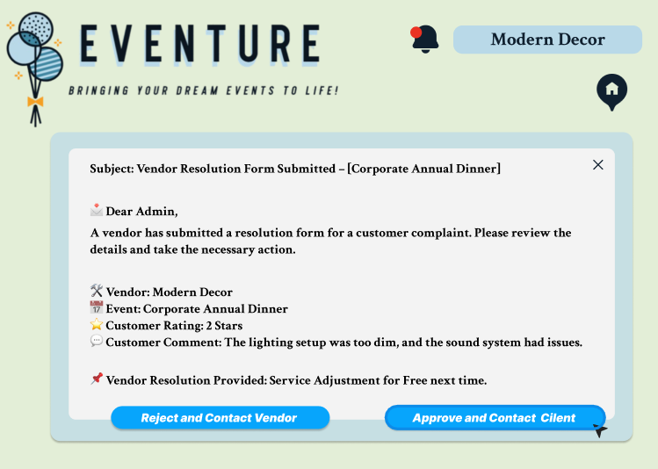

These pages allow admin to view the pending event, check for the event status, view the progress of the event, view the feedback that provide by customer and contact client to resolve the complaint or problem. The resolution will send later to the customer after vendor provide the solution and admin will base on the solution that vendor gives and send back to customer.

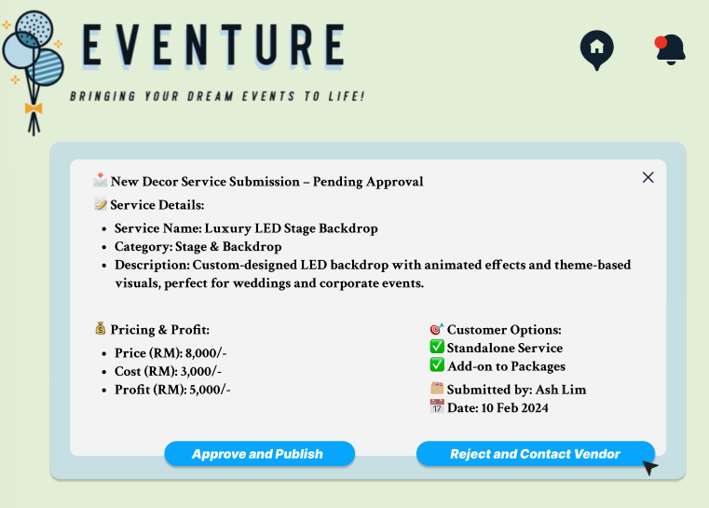

Admin can also make approve or reject the new deco service that requested by vendor.

Vendor information and Performance Review: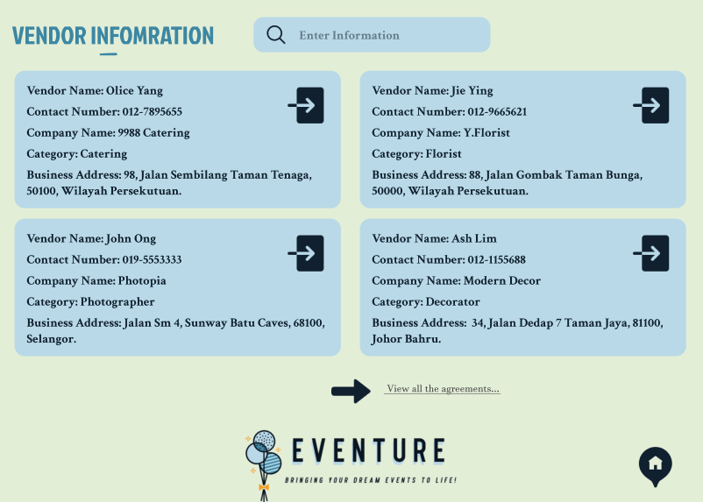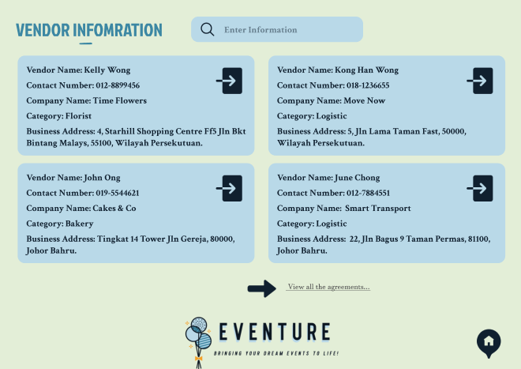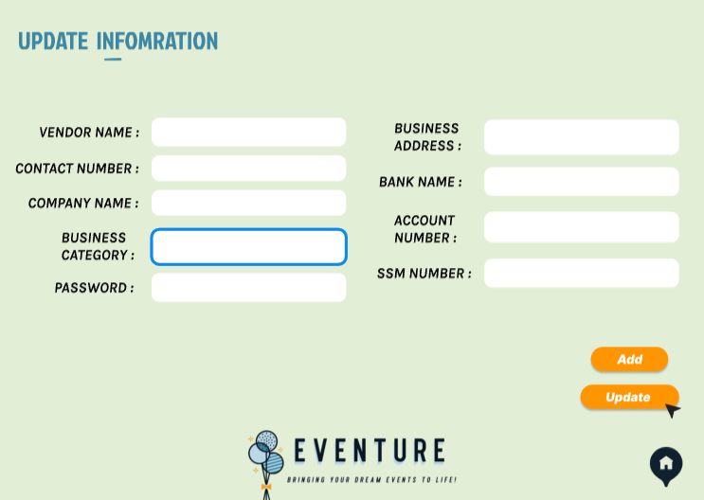

These pages allow admin to vendor information. If vendor wanted to make any changes of their personal information, admin could help them to do modifications and update their information. Admin also can add help new vendors to make registration through this system.

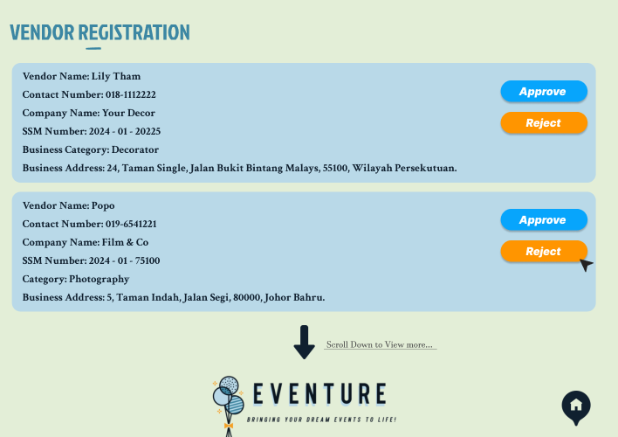

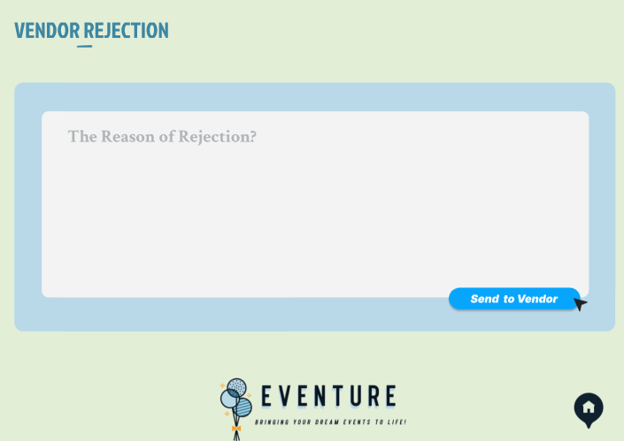

Admin can manage the registration of vendor, by accepting or reject their registration request.

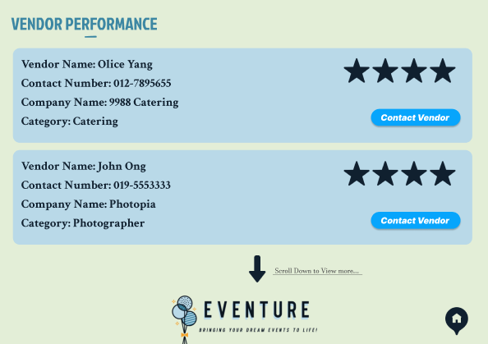

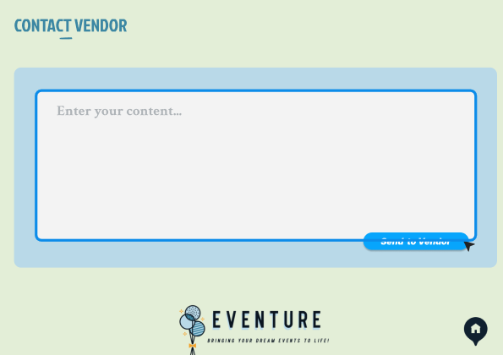

Admin also can view the vendor performance and contact vendor if there are any issues happend.

Financial Department

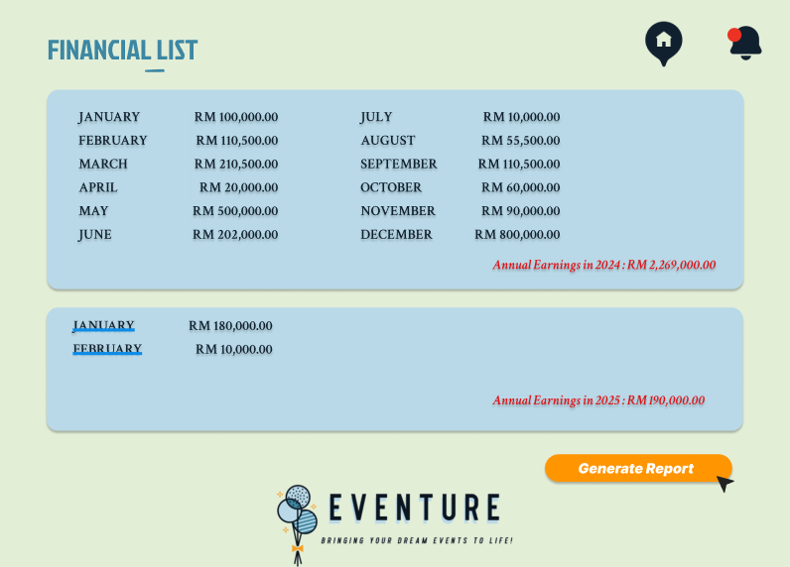

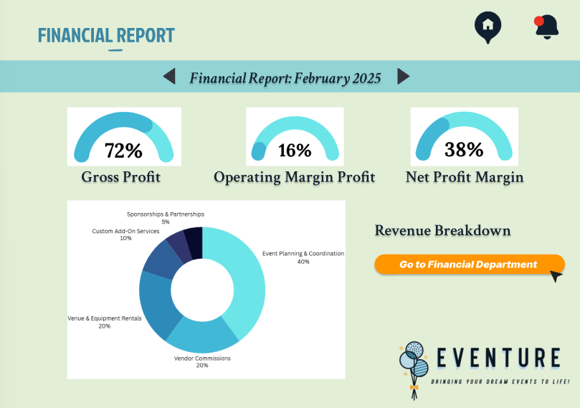

Admin are allowed to view for the financial list, from January to December, which means for the whole report. They also can click on “Generate report” to generate financial report, including graph, calculate of gross profit, operating margin profit and net profit margin in percentage.

Services chat box

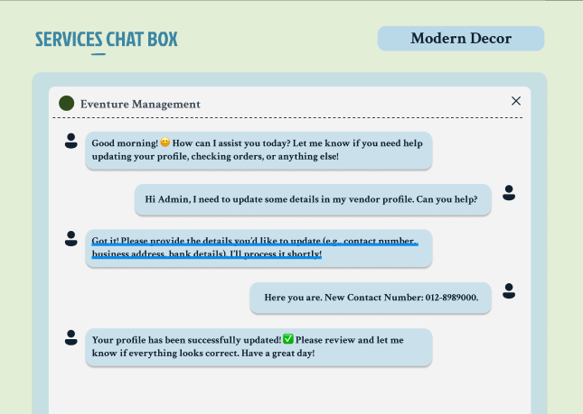

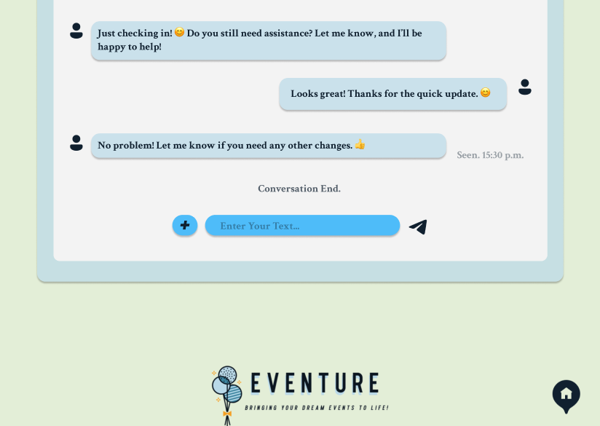

Eventure system provide chat box services, which allow to chat with admin, customer and vendor chat which each other. This is an example of using chat box services, vendor are chatting with admin for request on updating his vendor profile.

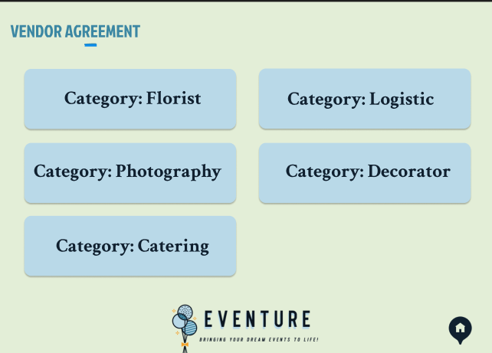

Eventure system also provide service like category of florist, logistic, photography, decorator and catering.

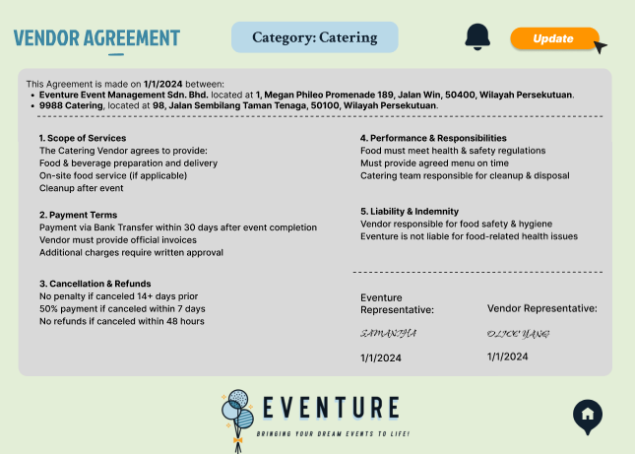.

This is one of the services that provided by Eventure system, which is Catering. It allows to generate contract between vendor and admin.

## 5.3 Testing

There are two suitable testing methods for the Eventure system which are system testing and User Acceptance Testing. System Testing ensures all system components integrate and function seamlessly. Conducted after integration testing, it verifies compliance with requirements by processing sample event data, vendor details, client bookings, and financial transactions. Critical functions like booking confirmations, vendor coordination, automated notifications, and financial tracking will be rigorously tested. The system’s capacity to handle high data volumes, generate reports, and maintain security will be assessed. Various valid and invalid inputs will test error handling, while performance evaluations measure responsiveness under multiple users. Cross-platform compatibility tests will ensure smooth operation across devices and browsers. Ultimately, this phase guarantees that all modules, from event scheduling to financial management, work together to meet business goals. (*Software Testing Methodologies*, n.d.)

Whereas, User Acceptance Testing (UAT) acts as the final validation, allowing real users event planners, vendors, and clients to assess usability. Users will simulate event management tasks, including event creation, vendor coordination, and financial tracking. Clients will navigate the portal, check updates, book events, and give feedback. Testers will document usability issues, and refinements will be made to enhance navigation, responsiveness, and accuracy. Automated notifications will be checked for timely delivery, and financial functions will be verified to ensure proper invoice generation and payment tracking. (Watson, 2025)

By incorporating both System Testing and UAT, Eventure guarantees technical reliability and user satisfaction, ensuring an efficient, user-friendly event management experience while maintaining a competitive edge.

## 5.4 System Deployment

**Parallel operation**

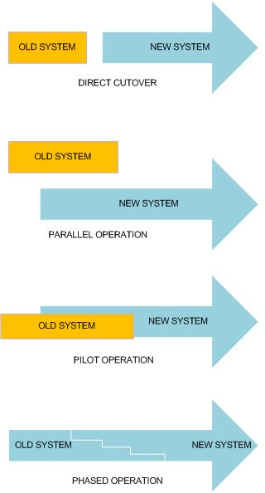

Parallel conversion is when a new system is fully operational after the old manual system has been running for a period. Both systems receive information inputs and the outputs generated by the updated system are compared with the corresponding outputs of the old system. Once management, the IT team, and users are satisfied with the expected functionality of the new system, the previous system is shut down. This approach is low risk because users can use the old system as a backup to prevent errors before making the necessary adjustments. This method provides the safest implementation strategy but is more costly because it runs two systems parallelly which can stress the operating system and slow down processing.

**Phased operation**



A **phased changeover** is a step-by-step system implementation approach where different parts of the new system are introduced gradually instead of replacing everything at once. Various modules or departments transition in stages, allowing for controlled testing, early issue detection, and smoother user adaptation.

One key benefit is the **reduced risk**, since only a portion of the system is introduced at a time, issues can be resolved before expanding further (Experts, 2023). This minimizes disruptions and ensures employees can continue using the old system while adjusting to the new one. The gradual transition helps users adapt more easily, reducing resistance and improving efficiency.

Another advantage is its **cost-effectiveness**. Unlike a parallel changeover, which requires running both systems simultaneously and increases expenses, a phased approach spreads costs over time, improving budget management. However, this method may extend the transition period and cause temporary compatibility issues between the old and new systems. Despite these challenges, a phased changeover remains a **practical and widely used** system implementation strategy.

**Best-Suited Changeover Method for Eventure Project**

For Eventure’s event management system, the **phased changeover** is the most suitable approach. Transitioning from a manual to a digital system requires a gradual shift to help employees, vendors, and clients adapt smoothly. Implementing the system in stages ensures that each module is tested and optimized before full deployment, reducing errors and improving overall efficiency (Experts, 2023).

This method also **minimizes disruptions** to business operations. Since event planning involves real-time coordination, a sudden system switch could cause workflow issues. A phased approach allows essential processes to continue while new features are introduced gradually. Additionally, it enables **early issue detection**, making troubleshooting easier and improving system stability.

From a **financial standpoint**, a phased changeover is cost-effective. Unlike a parallel approach that requires running two systems simultaneously, a gradual rollout eliminates unnecessary expenses. This ensures that Eventure can **effectively manage its RM 75,000 budget** while implementing key features step by step.

Overall, a phased changeover provides a **low-risk, structured, and scalable** transition for Eventure. It allows smooth adaptation, reduces operational disruptions, and ensures a financially efficient system deployment, making it the ideal choice.

# 6.0 References

(n.d.)., M. f. (2001). Retrieved from https://agilemanifesto.org/

activecollab. (2025 ). *Scrum Methodology: Game Changer for Small Teams*. Retrieved from activecollab: https://activecollab.com/learn/project-management-methodologies/scrum

Atlassian, B. (. (2020). Retrieved from https://www.atlassian.com/agile/project-management/waterfall-methodology#:~:text=Waterfall%20methodology%20is%20a%20well,%2C%20verification%2C%20and%20maintenance).

Atlassian, B. (.-b. (2020). Retrieved from https://www.atlassian.com/agile/project-management/waterfall-methodology

baeldung. (18 March, 2024). UML State Diagrams Explained. *UML State Diagrams Explained*.

Bigelow, S. J. (17 September, 2024). *CI/CD pipelines explained: Everything you need to know*. Retrieved from techtarget: https://www.techtarget.com/searchsoftwarequality/CI-CD-pipelines-explained-Everything-you-need-to-know

Chow, C. (16 February, 2022). *The 12 Principles of Agile*. Retrieved from Cybiant: https://www.cybiant.com/knowledge/the-12-principles-of-agile/

Creately. (12 December, 2022). *Sequence Diagram Tutorial – Complete Guide with Examples*. Retrieved from Creately: https://creately.com/guides/sequence-diagram-tutorial/#what-is-a-sequence-diagram

Experts, D. (04 April, 2023). *Phased Implementation*. Retrieved from dealhub: https://dealhub.io/glossary/phased-implementation/

GeeksForGeeks. (22 September, 2024). Rapid Application Development Model (RAD) – Software Engineering. *Rapid Application Development Model (RAD) – Software Engineering*.

geeksforgeeks. (22 May, 2024). *What is Scrum in Software Development?* Retrieved from geeksforgeeks: https://www.geeksforgeeks.org/scrum-software-development/

geeksforgeeks. (03 Jan, 2025). *Activity Diagrams – Unified Modeling Language (UML)*. Retrieved from geeksforgeeks: https://www.geeksforgeeks.org/unified-modeling-language-uml-activity-diagrams/

GeeksforGeeks. (3 January, 2025). State Machine Diagrams | Unified Modeling Language (UML). *State Machine Diagrams | Unified Modeling Language (UML)*.

GeeksforGeeks. (2024). Retrieved from https://www.geeksforgeeks.org/waterfall-model/

Gomez, J. (6 May, 2024). *The Spiral Model Explained*. Retrieved from Koombea: https://www.koombea.com/blog/spiral-model/

Guimaraes, P. (7 September, 2022). *Agile Principle #9 | Technical Excellence*. Retrieved from AllThingsAgile: https://allthingsagile.co/post/agile-principle-9/

Highsmith. (2009). Retrieved from https://www.google.com.my/books/edition/Agile_Project_Management/VuFpkztwPaUC?hl=en&gbpv=1&printsec=frontcover

Inc., C. (2023). Retrieved from https://www.cprime.com/resources/what-is-agile-what-is-scrum/

Iqbal, M. (9 February, 2022). How the 12 principles in the Agile Manifesto work in real life. *How the 12 principles in the Agile Manifesto work in real life*.

Kneafsey, S. (2023). Retrieved from https://www.scrum.org/resources/blog/agile-principles-sustainable-pace

Laoyan, S. (2024). Retrieved from https://asana.com/resources/waterfall-project-management-methodology

Malek, M. (05 May, 2023). *Agile Sprint Cycle: Manage Sprints Like a Pro*. Retrieved from itsdart: https://www.itsdart.com/blog/improving-sprint-cycles-to-get-more-done-in-less-time

Medeiros, R. (15 August, 2021). *The 12 Agile Principles Explained with Examples*. Retrieved from Scalable Path: https://www.scalablepath.com/project-management/12-agile-principles

Mir, M. A. (2 April, 2023). *What are the advantages and disadvantages of using Visual Studio Code or Atom?* Retrieved from Medium: https://medium.com/@ssc.ahmed.926748/what-are-the-advantages-and-disadvantages-of-using-visual-studio-code-or-atom-d3132bf1af85

Miseviciute, D. (09 September, 2024). *Scrum Team Size: Easy Steps to Create Ideal Team*. Retrieved from teamhood: https://teamhood.com/agile/scrum-team-size/

Molina, G. (21 February, 2022). Agile Principles Explained: Definitions and Examples for Software Development. *Agile Principles Explained: Definitions and Examples for Software Development*.

Paradigm, V. (2019). *What is Sequence Diagram?* Retrieved from Visual Paradigm: https://www.visual-paradigm.com/guide/uml-unified-modeling-language/what-is-sequence-diagram/

Platinumedge. (4 December, 2024). Retrieved from https://platinumedge.com/supporting-agile-principle-2-welcome-changes

Platinumedge. (4 December, 2024). Retrieved from https://platinumedge.com/supporting-agile-principle-1-customer-satisfaction

Qazi, I. (6 April, 2018). *Reflection on Principle 10 — Simplicity — the art of maximizing the amount of work not done — is essential.* Retrieved from Medium: https://medium.com/lapis/reflection-on-principle-10-simplicity-the-art-of-maximizing-the-amount-of-work-not-done-is-99520e0654dc

Radigan, D. (2025). *Product Backlog - What is it & How to create one*. Retrieved from atlassian: https://www.atlassian.com/agile/scrum/backlogs

Robinson, S. B. (18 10, 2024). Retrieved from https://www.google.com.my/books/edition/Agile_Project_Management/VuFpkztwPaUC?hl=en&gbpv=1&printsec=frontcover

Samuel. (15 January, 2023). *Spiral Vs Agile Methodologies Both are Iterative and Incremental. Why do we need both?* Retrieved from Medium: https://medium.com/@samyethio891/spiral-vs-agile-methodologies-both-are-iterative-and-incremental-why-do-we-need-both-ee135749cd23

Shimange, N. (20 June, 2023). *8 Benefits of HubSpot for Your Business*. Retrieved from Struto.io: https://www.struto.io/blog/8-hubspot-marketing-benefits

Singh, A. (16 July, 2024). *Shiksha Online*. Retrieved from Spiral Model in Software Engineering: https://www.shiksha.com/online-courses/articles/spiral-model-in-software-engineering/

Singh, R. (2024). Retrieved from https://instituteprojectmanagement.com/blog/waterfall-methodology/

Smyth, D. (n.d.). Changeover Techniques. *Changeover Techniques*.

Snook, R. (2023). Retrieved from https://rupertsnook.medium.com/book-summary-for-lean-software-development-an-agile-toolkit-7082b9bdc02

Snook, R. (2023). Retrieved from https://rupertsnook.medium.com/book-summary-for-lean-software-development-an-agile-toolkit-7082b9bdc02

Staff, C. (26 September, 2024). *What Are the Agile Principles?* Retrieved from coursera: https://www.coursera.org/articles/agile-principles

Szmit, A. (03 March, 2023). *The reflection of a Sprint Retrospective*. Retrieved from bigpicture: https://bigpicture.one/blog/a-reflection-of-a-sprint-retrospective/

Talreja, A. (18 August, 2024). *Understanding the Spiral Model in Software Development*. Retrieved from Teaching Agile: https://teachingagile.com/sdlc/models/spiral

Tenhundfeld, A. (12 March, 2022). *Agile Principles: Adaptive Self-Organizing*. Retrieved from simplethread: https://www.simplethread.com/agile-principles-11-adaptive-self-organizing/

visual Paradigm. (n.d.). What is State Machine Diagram? *What is State Machine Diagram?*

visual-paradigm. (2024). *What is Activity Diagram?* Retrieved from visual-paradigm: https://www.visual-paradigm.com/guide/uml-unified-modeling-language/what-is-activity-diagram/

Vyas, K. (3 February, 2023). *8 Major Advantages of Using MySQL*. Retrieved from Datamation: https://www.datamation.com/storage/8-major-advantages-of-using-mysql/

What are the four system changeover methods? (17 December, 2020). *What are the four system changeover methods?*

Wisbey, O. (March, 2023). *Sequence Diagram*. Retrieved from Tech Target: https://www.techtarget.com/searchsoftwarequality/definition/sequence-diagram

WisdomAnswer. (17 December, 2020). What are the four system changeover methods? *What are the four system changeover methods?*

WisdomAnswer. (31 December, 2020). What are the system changeover methods? *What are the system changeover methods?*

Zhuravel, H. (15 September, 2024). How Can Your Business Benefit from RAD Development. *How Can Your Business Benefit from RAD Development*.

zoho. (2025). *Sprint review:*. Retrieved from zoho: https://www.zoho.com/sprints/sprint-reviews.html

Educative. (n.d.). What are include and extend relationships in a use case diagram?

[https://www.educative.io/answers/what-are-include-and-extend-relationships-in-a-use-case  
diagram](https://www.educative.io/answers/what-are-include-and-extend-relationships-in-a-use-casediagram)

Jalote, P., Palit, A., Kurien, P., & Peethamber, V. T. (2004). Timeboxing: a process model for

iterative software development. Journal of Systems and Software, 70(1-2), 117–127.

<https://doi.org/10.1016/s0164-1212(03)00010-4>

ProductPlan. (2024, November 22). What are the 12 Agile Principles? | Definition and Overview.  
[https://www.productplan.com/glossary/agile-principles/#:~:text=“Welcome%20changing%20requirements%2C%20even%20late,forward%20in%20spite%20of%20them.](https://www.productplan.com/glossary/agile-principles/#:~:text=)

What is the Rational Unified Process? - Methodology, Tools & Examples | Study.com. (2020). Study.com.

<https://study.com/academy/lesson/what-is-the-rational-unified-process-methodology-tools-examples.html>

‌RUP: Definition, Phases, Advantages and Best Practices. (2024). Indeed Career Guide. <https://www.indeed.com/career-advice/career-development/rup>

GeeksforGeeks. (2024, May 22). What is RUP(Rational Unified Process) and its Phases? GeeksforGeeks.

<https://www.geeksforgeeks.org/rup-and-its-phases/>

‌Rodina, D. (n.d.) Use case diagram’s include and extend Demystified - Software Ideas Modeler.

<https://www.softwareideas.net/a/1812/use-case-diagram-s-include-and-extend-demystified>

Watson, M. (2025, January 20). 8 Essential system testing Methods for software quality Success - Full scale. Full Scale.

<https://fullscale.io/blog/system-testing/>

Software testing methodologies. (n.d.). smartbear.com.

<https://smartbear.com/learn/automated-testing/software-testing-methodologies/>

(n.d.)., M. f. (2001). Retrieved from https://agilemanifesto.org/

activecollab. (2025 ). *Scrum Methodology: Game Changer for Small Teams*. Retrieved from activecollab: https://activecollab.com/learn/project-management-methodologies/scrum

Atlassian, B. (. (2020). Retrieved from https://www.atlassian.com/agile/project-management/waterfall-methodology#:~:text=Waterfall%20methodology%20is%20a%20well,%2C%20verification%2C%20and%20maintenance).

Atlassian, B. (.-b. (2020). Retrieved from https://www.atlassian.com/agile/project-management/waterfall-methodology

baeldung. (18 March, 2024). UML State Diagrams Explained. *UML State Diagrams Explained*.

Bigelow, S. J. (17 September, 2024). *CI/CD pipelines explained: Everything you need to know*. Retrieved from techtarget: https://www.techtarget.com/searchsoftwarequality/CI-CD-pipelines-explained-Everything-you-need-to-know

Chow, C. (16 February, 2022). *The 12 Principles of Agile*. Retrieved from Cybiant: https://www.cybiant.com/knowledge/the-12-principles-of-agile/

Creately. (12 December, 2022). *Sequence Diagram Tutorial – Complete Guide with Examples*. Retrieved from Creately: https://creately.com/guides/sequence-diagram-tutorial/#what-is-a-sequence-diagram

Experts, D. (04 April, 2023). *Phased Implementation*. Retrieved from dealhub: https://dealhub.io/glossary/phased-implementation/

GeeksForGeeks. (22 September, 2024). Rapid Application Development Model (RAD) – Software Engineering. *Rapid Application Development Model (RAD) – Software Engineering*.

geeksforgeeks. (22 May, 2024). *What is Scrum in Software Development?* Retrieved from geeksforgeeks: https://www.geeksforgeeks.org/scrum-software-development/

geeksforgeeks. (03 Jan, 2025). *Activity Diagrams – Unified Modeling Language (UML)*. Retrieved from geeksforgeeks: https://www.geeksforgeeks.org/unified-modeling-language-uml-activity-diagrams/

GeeksforGeeks. (3 January, 2025). State Machine Diagrams | Unified Modeling Language (UML). *State Machine Diagrams | Unified Modeling Language (UML)*.

GeeksforGeeks. (2024). Retrieved from https://www.geeksforgeeks.org/waterfall-model/

Gomez, J. (6 May, 2024). *The Spiral Model Explained*. Retrieved from Koombea: https://www.koombea.com/blog/spiral-model/

Guimaraes, P. (7 September, 2022). *Agile Principle #9 | Technical Excellence*. Retrieved from AllThingsAgile: https://allthingsagile.co/post/agile-principle-9/

Highsmith. (2009). Retrieved from https://www.google.com.my/books/edition/Agile_Project_Management/VuFpkztwPaUC?hl=en&gbpv=1&printsec=frontcover

Inc., C. (2023). Retrieved from https://www.cprime.com/resources/what-is-agile-what-is-scrum/

Iqbal, M. (9 February, 2022). How the 12 principles in the Agile Manifesto work in real life. *How the 12 principles in the Agile Manifesto work in real life*.

Kneafsey, S. (2023). Retrieved from https://www.scrum.org/resources/blog/agile-principles-sustainable-pace

Laoyan, S. (2024). Retrieved from https://asana.com/resources/waterfall-project-management-methodology

Malek, M. (05 May, 2023). *Agile Sprint Cycle: Manage Sprints Like a Pro*. Retrieved from itsdart: https://www.itsdart.com/blog/improving-sprint-cycles-to-get-more-done-in-less-time

Medeiros, R. (15 August, 2021). *The 12 Agile Principles Explained with Examples*. Retrieved from Scalable Path: https://www.scalablepath.com/project-management/12-agile-principles

Mir, M. A. (2 April, 2023). *What are the advantages and disadvantages of using Visual Studio Code or Atom?* Retrieved from Medium: https://medium.com/@ssc.ahmed.926748/what-are-the-advantages-and-disadvantages-of-using-visual-studio-code-or-atom-d3132bf1af85

Miseviciute, D. (09 September, 2024). *Scrum Team Size: Easy Steps to Create Ideal Team*. Retrieved from teamhood: https://teamhood.com/agile/scrum-team-size/

Molina, G. (21 February, 2022). Agile Principles Explained: Definitions and Examples for Software Development. *Agile Principles Explained: Definitions and Examples for Software Development*.

Paradigm, V. (2019). *What is Sequence Diagram?* Retrieved from Visual Paradigm: https://www.visual-paradigm.com/guide/uml-unified-modeling-language/what-is-sequence-diagram/

Platinumedge. (4 December, 2024). Retrieved from https://platinumedge.com/supporting-agile-principle-2-welcome-changes

Platinumedge. (4 December, 2024). Retrieved from https://platinumedge.com/supporting-agile-principle-1-customer-satisfaction

Qazi, I. (6 April, 2018). *Reflection on Principle 10 — Simplicity — the art of maximizing the amount of work not done — is essential.* Retrieved from Medium: https://medium.com/lapis/reflection-on-principle-10-simplicity-the-art-of-maximizing-the-amount-of-work-not-done-is-99520e0654dc

Radigan, D. (2025). *Product Backlog - What is it & How to create one*. Retrieved from atlassian: https://www.atlassian.com/agile/scrum/backlogs

Robinson, S. B. (18 10, 2024). Retrieved from https://www.google.com.my/books/edition/Agile_Project_Management/VuFpkztwPaUC?hl=en&gbpv=1&printsec=frontcover

Samuel. (15 January, 2023). *Spiral Vs Agile Methodologies Both are Iterative and Incremental. Why do we need both?* Retrieved from Medium: https://medium.com/@samyethio891/spiral-vs-agile-methodologies-both-are-iterative-and-incremental-why-do-we-need-both-ee135749cd23

Shimange, N. (20 June, 2023). *8 Benefits of HubSpot for Your Business*. Retrieved from Struto.io: https://www.struto.io/blog/8-hubspot-marketing-benefits

Singh, A. (16 July, 2024). *Shiksha Online*. Retrieved from Spiral Model in Software Engineering: https://www.shiksha.com/online-courses/articles/spiral-model-in-software-engineering/

Singh, R. (2024). Retrieved from https://instituteprojectmanagement.com/blog/waterfall-methodology/

Smyth, D. (n.d.). Changeover Techniques. *Changeover Techniques*.

Snook, R. (2023). Retrieved from https://rupertsnook.medium.com/book-summary-for-lean-software-development-an-agile-toolkit-7082b9bdc02

Snook, R. (2023). Retrieved from https://rupertsnook.medium.com/book-summary-for-lean-software-development-an-agile-toolkit-7082b9bdc02

Staff, C. (26 September, 2024). *What Are the Agile Principles?* Retrieved from coursera: https://www.coursera.org/articles/agile-principles

Szmit, A. (03 March, 2023). *The reflection of a Sprint Retrospective*. Retrieved from bigpicture: https://bigpicture.one/blog/a-reflection-of-a-sprint-retrospective/

Talreja, A. (18 August, 2024). *Understanding the Spiral Model in Software Development*. Retrieved from Teaching Agile: https://teachingagile.com/sdlc/models/spiral

Tenhundfeld, A. (12 March, 2022). *Agile Principles: Adaptive Self-Organizing*. Retrieved from simplethread: https://www.simplethread.com/agile-principles-11-adaptive-self-organizing/

visual Paradigm. (n.d.). What is State Machine Diagram? *What is State Machine Diagram?*

visual-paradigm. (2024). *What is Activity Diagram?* Retrieved from visual-paradigm: https://www.visual-paradigm.com/guide/uml-unified-modeling-language/what-is-activity-diagram/

Vyas, K. (3 February, 2023). *8 Major Advantages of Using MySQL*. Retrieved from Datamation: https://www.datamation.com/storage/8-major-advantages-of-using-mysql/

What are the four system changeover methods? (17 December, 2020). *What are the four system changeover methods?*

Wisbey, O. (March, 2023). *Sequence Diagram*. Retrieved from Tech Target: https://www.techtarget.com/searchsoftwarequality/definition/sequence-diagram

WisdomAnswer. (17 December, 2020). What are the four system changeover methods? *What are the four system changeover methods?*

WisdomAnswer. (31 December, 2020). What are the system changeover methods? *What are the system changeover methods?*

Zhuravel, H. (15 September, 2024). How Can Your Business Benefit from RAD Development. *How Can Your Business Benefit from RAD Development*.

zoho. (2025). *Sprint review:*. Retrieved from zoho: https://www.zoho.com/sprints/sprint-reviews.html

# 7.0 Workload Matrix

